St Joseph's



Pre-School

Registered Charity Number 1089094

Dear Parents & Carers,

  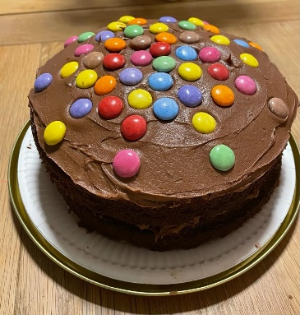 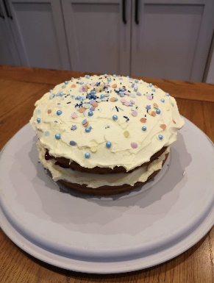 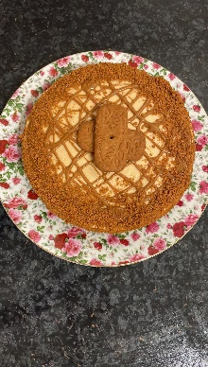

We are pleased to announce that the next Pre-School Cake Raffle will be drawn on Friday 17th March.

Tickets are on sale from **Monday 13th March to Thursday 16th March**. **£1 per ticket**

**Cash**

Look for Anna Hitchings or Leah Farrer on drop off or pick up to get your tickets. Alternatively our wonderful year 6 volunteers will be in the playground every afternoon at pick up.

**Paypal**

[stjosephpstreasurer@gmail.com](mailto:stjosephpstreasurer@gmail.com) **Please select friends and family or we get charged to receive the payment.**

**Bank**

Account name: St Josephs Hill Tots Preschool, Account number: 01370405, Sort code: 40-19-32

Once you have made your payment simply email the Preschool on the same email address ([stjosephpstreasurer@gmail.com](mailto:stjosephpstreasurer@gmail.com)) and let them know you have paid and the name (and year) of the child you wish the cake to come home with.

Future raffles will be drawn on:

Friday 12th May Friday 23rd June

If you would like to be our volunteer baker for one of these please get in touch with Anna ([stjosephspresch@gmail.com](mailto:stjosephspresch@gmail.com)).

Thank you for your continued support

St Joseph’s Preschool Committee