|  |  |  |
| --- | --- | --- |
| **Friday 27th March 2020 Money** | How am I doing? | |
| Teacher | Me |
| KITE – Find the sum of different amounts of pence. |  |  |



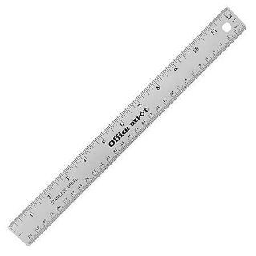

Do it

REACH

|  |
| --- |
| **Do it:**  **Calculate:**  **10p + 5p =**  **20p + 25p =**  **27p + 23p =**  **28p + 24p =**  **20p + 39p + 4p =**  **____ = 16p + 8p + 20p**  **____ = 17p + 9p + 10p**  **____ = 15p + 7p + 20p**  **____ = 14p + 3p + 10p** |
| **Secure it**  **Miss Jones thinks that:**  **10p + 5p = 15**  **Explain why she is incorrect.** |

|  |
| --- |
| **Deepen it**  **Coco buys three items.**  **Investigate how much she could have spent.**    **What is the least and most she could have spent?** |