|  |  |  |
| --- | --- | --- |
| **Tuesday 24th March 2020 Money** | How am I doing? | |
| Teacher | Me |
| KITE – Find the sum of different amounts of pounds. |  |  |



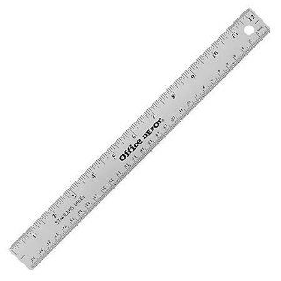

Do it

REACH

|  |
| --- |
| **Do it:**  **What is the total of each set?** |
| **Secure it**  **Miss Jones thinks that the total of £10 and £5 is £60.**  **Explain why she is incorrect.** |

|  |
| --- |
| **Deepen it**  **Colin buys three items.**  **Investigate how much he could have spent.**  **What is the least and most he could have spent?** |