|  |  |  |
| --- | --- | --- |
| **Wednesday 1st April 2020 Money** | How am I doing? | |
| Teacher | Me |
| KITE – Calculate change from £1. |  |  |

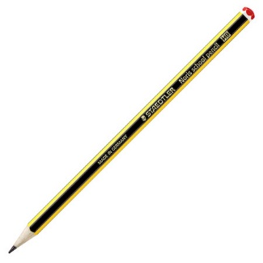

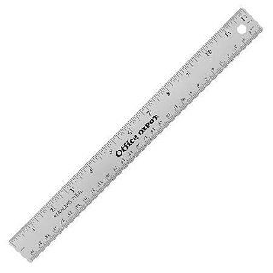

Do it

REACH

|  |
| --- |
| **Do it:**  **Calculate the change from £1 if you spend:**  **30p**  **35p**  **5p**  **47p**  **82p**  **What coins will you get each time?** |
| **Secure it**  **Miss Jones thinks that the change from £1 after appending 55p would be a 40p coin and a 5p coin.**  **Explain why she is incorrect.** |

|  |
| --- |
| **Deepen it**  **Coco starts with £1.**  **She spends some money and gets two silver coins for her change.**  **Investigate how much she could have spent.** |