|  |  |  |
| --- | --- | --- |
| **Tuesday 31st March 2020 Money** | How am I doing? | |
| Teacher | Me |
| KITE – Calculate change from 50p. |  |  |

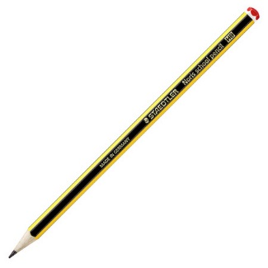

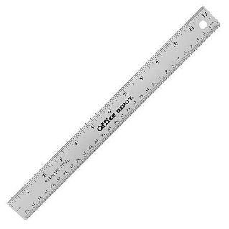

Do it

REACH

|  |
| --- |
| **Do it:**  **Calculate the change from 50p if you spend:**  **30p**  **35p**  **5p**  **17p**  **What coins will you get each time?** |
| **Secure it**  **Miss Jones thinks that if she has 50p and spends 32p she will get 28p change.**  **Explain why she is incorrect.** |

|  |
| --- |
| **Deepen it**  **Find the missing digits.**    **Solve each line in several ways where possible.**  **Solve it using the digits 0, 1, 2, 3, 4, 5, 6, 7, and 8 once.** |