Monday 30th March – Phonics
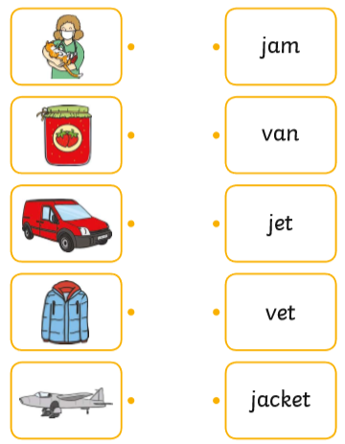
Match the picture to the word by drawing a line between both.

