###### THINKTRAVEL_IDENTITY_STRAPLINE (2)

###### Levels 1 & 2 Bikeability Cycle Training

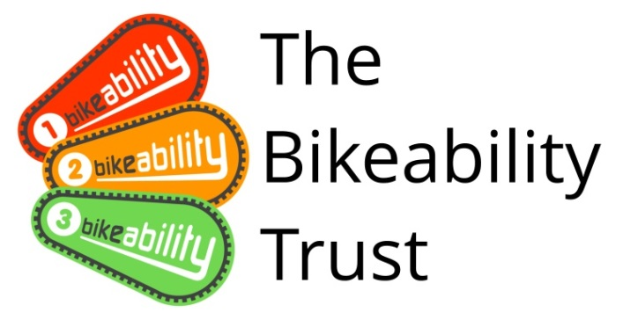

**WHAT IS BIKEABILITY?** Bikeability is the national cycle training programme supported and funded by the Department for Transport. The course builds the skills and confidence of children who can already ride. Bikeability doesn’t only make children better cyclists - potentially for the rest of their lives - but can help with general confidence and independent thinking. All of our Bikeability training is delivered by qualified, professional, DBS checked National Standard Instructors. Visit www.bikeability.org.uk for more information.

This practical and enjoyable training will-

* Help your child develop their skills and understanding as a safe road user.
* Help them to be physically active and safe as part of a healthy lifestyle.
* Help their personal development building self confidence and independence.

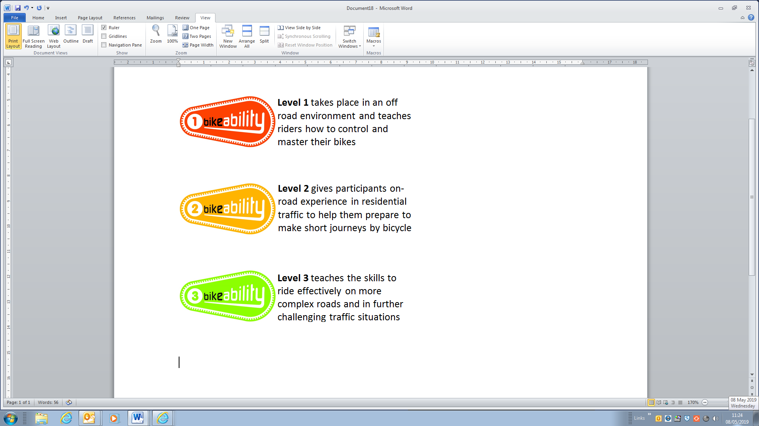

**If you would like your child to take part please read through the following information.**

**This course** develops the cycling skills and confidence of children who can already cycle. To benefit from Bikeability, your child must attend every session and practice what they learn after training. Bikeability skills and confidence will be lost without regular cycling. Bikeability engenders enthusiasm while building skills and confidence to cycle more safely, more often. Please support and encourage your child to continue cycling after training.

**HOW TO BOOK** Bikeability places are limited and places will be booked on a first come basis. Please complete and return a consent form (see overleaf) **to school** as soon as possible.

**Privacy Information**

Any information you provide will be treated as confidential and in accordance with UK data protection legislation. We will keep and use your information for booking, organising and conducting road safety cycle training as part of the Bikeability Scheme. With your full consent, we may also photograph and/or film your child taking part in the scheme to help promote Bikeability. The information provided may also be shared with the Department for Transport, and be used for the wider purpose of providing statistical data used to assist with monitoring provision and applying for funding where relevant. Any information provided will not be shared with or passed on to any other third party. For full information on how we use your and your child’s information, and how to exercise your rights under the Data Protection Act, please visithttps://www.gloucestershire.gov.uk/council-and-democracy/data-protection/service-specific-privacy-.

Training is delivered on behalf of the school by Gloucestershire County Council, Shire Hall, Gloucester, GL1 2TH. Tel. (01452) 425926e-mail [roadsafety@gloucestershire.gov.uk](mailto:roadsafety@gloucestershire.gov.uk)

**We also offer** Advanced Level 3 cycle training at Secondary Schools throughout the County. When your child moves school please ask about this during Year 7.

**Covid-19**

All our instructors are closely following the Government’s Covid-19 guidelines to ensure that Bikeability training is delivered safely with strict adherence to regulations on **social distancing** and the use of **PPE**.

**PRE-COURSE BIKE SAFETY CHECK –** Before bringing your child’s bike to school for the course please check the following …

|  |
| --- |
| **Remember your…** |
| **A**  Ensure both your front and back brakes work properly  Clean and oil your chain regularly to ensure that it is running smoothly  Run through all your gears  Check both your front and back tyres are pumped up  Make sure your handlebars, wheels and saddle are fixed on tight |
| **Air** |
| **B** |
| **Brakes** |
| **C** |
| **Chain** |
| **before every ride** |

**PARENT/ GUARDIAN – CONSENT FORM** Please read the following information before completing and returning the consent slip to your child’s school.

|  |  |
| --- | --- |
| **COURSE INFORMATION** | **WHAT WILL YOUR CHILD NEED?** |
| * Bikeability Levels 1 and 2 * Dates – week commencing 20th June 2022 * Cost – £8.50 (unless eligible for free school meals) | • A complete consent form (see below)  • A roadworthy bike without stabilisers (see ABC checklist above)  • A helmet  • Suitable clothing for the weather conditions |

WB01387_………………………………………………………………………………………………………………………………………………………………..

**I understand that (please tick):**

* I agree to my son/daughter taking part in cycle training.
* My son/daughter can already ride a bike (you child will be unable to do L2 Bikeability if they cannot ride a bike).
* The instructors may refuse to train my child if they deem his/her cycle to be un-roadworthy.
* It remains my responsibility to ensure my child does not ride an un-roadworthy bike and if I am in doubt as to whether a cycle is roadworthy I should seek the advice of a professional mechanic.
* Instructors may at any time refuse to continue to train my child if his/her behaviour or cycling ability is deemed unsuitable.
* Gloucestershire County Council will not be responsible for any injury or liable for any loss or damage to participant’s cycles and other belongings.
* It is recommended that trainees wear a helmet and it may be a requirement of the school.
* I agree to encourage my child to practice between each session and after the completion of training.
* I consent to the Bikeability instructor ‘adjusting’ my child’s helmet if required, however I confirm they are not responsible for the physical condition or appropriate fitting of the helmet.
* I consent to qualified instructors administering first aid to my child if required.
* I understand that pupil data collected will be used to support the delivery and monitoring of training sessions/courses.
* I understand that aggregated and anonymised data will be shared with the Department of Transport for monitoring purposes.

Please see https://www.gloucestershire.gov.uk/council-and-democracy/data-protection/service-specific-privacy-notices/ for further details about how we use and share your and your child’s data.

|  |  |
| --- | --- |
| Full Name of Child: |  |
| Are there any medical/ educational needs we need to be aware of? |  |

If you are happy for your child to be photographed and/or filmed to help promote Bikeability via GCC social media, website, press, promotional materials, documents and reports, printed or digital, please tick here.

From September 2021 The Department of Transport have asked that Schools collect and report on the ethnicity of children attending Bikeability sessions for equalities monitoring purposes. This data will be anonymised when it is sent to the Department of Transport, but it does mean that your child’s ethnicity will be recorded on Cycle Ready, our internal booking management system. Please note that your child’s enrolment onto the Bikeability course will not be affected if you choose not to consent to this.

Please tick here if you consent to your child’s ethnicity data being processed in the above manner



I confirm that I have read all the information enclosed in the ‘Parental Consent Form’ and consent to my child (or the above child for whom I take responsibility) to take cycling lessons and related activities, which may include cycle maintenance as well as riding on the public highway. I understand that this information is retained by my child’s school and used to ensure my child is eligible to undertake Bikeability training.

|  |  |
| --- | --- |
| Signed (parent/guardian) : |  |
| Date: |  |

## To be returned to the school- The school should retain this form when it has been returned.

**Love to Ride**

Gloucestershire County Council is currently promoting **Love to Ride** as tool for increasing adult participation in cycling. Click on [www.lovetoride.net](http://www.lovetoride.net) to register, log rides, chances to win prizes and be part of the Gloucestershire cycling community through work place or individual engagement.

