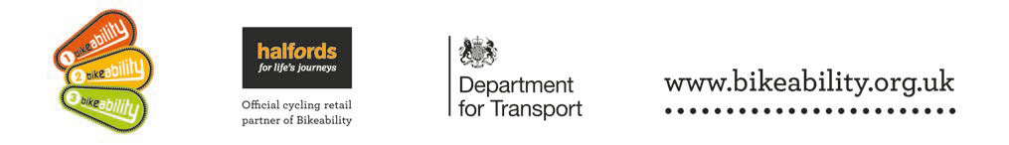

Levels 1 & 2 Bikeability Cycle Training

WHAT IS BIKEABILITY? Bikeability is the national cycle training programme supported and funded by the Department for Transport. The course builds the skills and confidence of children who can already ride. Bikeability doesn’t only make children better cyclists - potentially for the rest of their lives - but can help with general confidence and independent thinking. All of our Bikeability training is delivered by qualified, professional, DBS checked National Standard Instructors. Visit www.bikeability.org.uk for more information
This practical and enjoyable training will-
- Help your child develop their skills and understanding as a safe road user.
- Help them to be physically active and safe as part of a healthy lifestyle.
- Help their personal development building self confidence and independence.
If you would like them to take part please read through the following information.
This course develops the cycling skills and confidence of children who can already cycle. To benefit from Bikeability, your child must attend every session and practice what they learn after training. Bikeability skills and confidence will be lost without regular cycling. Bikeability engenders enthusiasm while building skills and confidence to cycle more safely, more often. Please support and encourage your child to continue cycling after training.
Covid-19
All our instructors are closely following the Government’s Covid-19 guidelines to ensure that Bikeability training is delivered safely with strict adherence to regulations on social distancing and the use of PPE.
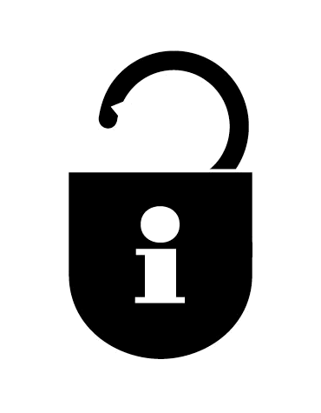
HOW TO BOOK Bikeability places are limited and places will be booked on a first come basis. Please complete and return a consent form (see overleaf) to school as soon as possible.
DPA 2018 - We will keep and use your information for booking, organising and conducting road safety cycle training as part of the Bikeability Scheme. The information provided may also be used for the wider purpose of providing statistical data used to assist with monitoring provision and applying for funding where relevant. All information will be stored in line with the relevant Data Protection legislation.
For full information on how we use your information please visit www.gloucestershire.gov.uk/privacynotice.
Training is delivered on behalf of the school by Gloucestershire County Council, Shire Hall, Gloucester, GL1 2TH. Tel. (01452) 425926 e-mail roadsafety@gloucestershire.gov.uk
We also offer Advanced Level 3 cycle training at Secondary Schools throughout the County. When your child moves school please ask about this during Year 7.
FREE HALFORDS BIKE CHECK, DISCOUNT VOUCHER AND PRIZE DRAW Overleaf we show you how to safety check your bike, however why not also get a professional mechanic to check over your bike free of charge, through our exclusive partnership with Halfords, the nation’s biggest cycling retailer? All you need to do, to receive some amazing incentives, is register at: bikeability.org.uk/participants-hub
REGISTER NOW TO RECEIVE THE FOLLOWING FROM HALFORDS:
1. A free bike safety check by a trained mechanic at all stores nationwide
2. A voucher with money off incentives (exclusive money off discounts for Bikeability participants and their families)
3. Entry into a prize draw to win a free Carrera kids bike
Once registered you will receive an email confirming your free offers.
PRE-COURSE BIKE SAFETY CHECK
Visit Halfords online safety check www.halfords.com/cycling/bike-maintenance/care-plans/free-bike-check
Remember your…
A
Ensure both your front and back brakes work properly
Clean and oil your chain regularly to ensure that it is running smoothly
Run through all your gears
Check both your front and back tyres are pumped up
Make sure your handlebars, wheels and saddle are fixed on tight
Air
B
Brakes
C
Chain
before every ride

PARENT/ GUARDIAN – CONSENT FORM Please read the following information before completing and returning the consent slip to your child’s school.
COURSE INFORMATION | WHAT WILL YOUR CHILD NEED?
- Bikeability Levels 1 and 2  - Dates – week commencing 21st June 2021  - Cost – £8.50 (unless eligible for free school meals) | • A complete consent form (see below)  • A roadworthy bike without stabilisers (see ABC checklist above)  • A helmet if required  • Suitable clothing for the weather conditions
………………………………………………………………………………………………………………………………………………………………..
I understand that:
1. I agree to my son/daughter taking part in cycle training
2. My son/daughter can already ride (may be refused if not)
3. The instructors may refuse to train my child if they deem his/her cycle to be un-roadworthy
4. It remains my responsibility to ensure my child does not ride an un-roadworthy bike and if I am in doubt as to whether a cycle is roadworthy I should seek the advice of a professional mechanic
5. Instructors may at any time refuse to continue to train my child if his/her behaviour or cycling ability is deemed unsuitable
6. Gloucestershire County Council will not be responsible for any injury or liable for any loss or damage to participant’s cycles and other belongings.
7. It is recommended that trainees wear a helmet and it may be a requirement of the school.
8. I consent to the Bikeability instructor ‘adjusting’ my child’s helmet if required, however I confirm they are not responsible for the physical condition or appropriate fitting of the helmet
9. I consent to qualified instructors administering first aid to my child if required.
10. I understand that pupil data collected will be used to support the delivery and monitoring of training sessions/courses.
See bikeability.org.uk/privacy-statement/ for further details.
11. I agree to encourage my child to practice between each session and after the completion of training

Full Name of Child:

Are there any medical/ educational needs we need to be aware of?
If you are happy for your child to be photographed and/or filmed to help promote Bikeability via GCC social media, website, press, promotional materials, documents and reports, printed or digital, please tick here
I confirm that I have read all the information enclosed and in the ‘Parental Consent Form’ and consent to my child (or the above child for whom I take responsibility) to take cycling lessons and related activities, which may include cycle maintenance as well as riding on the public highway. I understand that this information is retained by my child’s school and used to ensure my child is eligible to undertake Bikeability training.

Signed (parent/guardian) :

Date:

To be returned to the school- The school should retain this form when it has been returned

