Friday 3rd April – Phonics
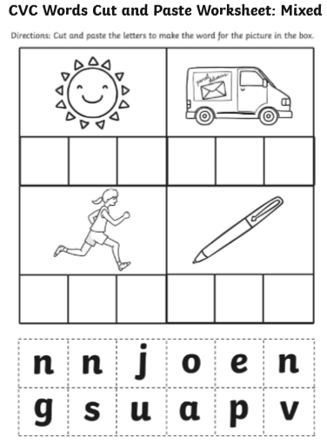
Cut the letters and stick them on to make the word for the picture in the box. If you do not have scissors or a glue stick, then write the letters to make the word.

