
Handwriting
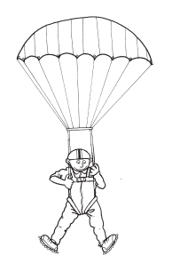
Book B
Sue Peet

William Collins’ dream of knowledge for all began with the publication of his first book in 1819. A self-educated mill worker, he not only enriched millions of lives, but also founded a flourishing publishing house. Today, staying true to this spirit, Collins books are packed with inspiration, innovation and practical expertise. They place you at the centre of a world of possibility and give you exactly what you need to explore it.
Collins. Freedom to teach.
Published by Collins
An imprint of HarperCollinsPublishers
77–85 Fulham Palace Road
Hammersmith
London
W6 8JB
Browse the complete Collins
Education catalogue at
www.collinseducation.com
Text, design and illustrations © HarperCollinsPublishers Ltd 2011
Previously published as Spectrum Handwriting by Folens Ltd,
first published 2000.
10 9 8 7 6 5 4 3 2 1
ISBN: 978-0-00-742700-0
Sue Peet asserts her moral right to be identified as the author of this work.
Any educational institution that has purchased one copy of this publication may make unlimited duplicate copies for use exclusively within that institution. Permission does not extend to reproduction, storage within a retrieval system, or transmittal in any form or by any means, electronic, mechanical, photocopying, recording or otherwise, of duplicate copies for loaning, renting or selling to any other institution without the permission of the Publisher.
British Library Cataloguing in Publication Data
A Catalogue record for this publication is available from the British Library.
Acknowledgements
Fonts from Handwriting for Windows used with the permission of KBER.
Every effort has been made to trace copyright holders and to obtain their permission for the use of copyright material. The authors and publishers will gladly receive any information enabling them to rectify any error or omission in subsequent editions.
Design: Mark Walker
Illustrations: Chantal Kees
Cover design: LCD
Cover illustration: Gwyneth Williamson
Printed and bound by Martins the Printers, Berwick-upon-Tweed.

Mixed Sources
Product group from well-managed
forests and other controlled sources
www.fsc.org Cert no. SW-COC-1806
© 1996 forest Stewardship Council
FSC is a non-profit international organisation established to promote the responsible management of the world's forests. Products carrying the FSC label are independently certified to assure consumers that they come from forests that are managed to meet the social, economic and ecological needs of present and future generations.
Find out more about HarperCollins and the environment at
www.harpercollins.co.uk/green



Page
Contents
Programme overview 4–5
Teacher notes 6–16
1 Practising patterns 17
2 Look out below! 18
3 Time for lunch 19
4 Practising patterns 20
5 Mice on the run! 21
6 Here comes the water! 22
7 One jump ahead 23
8 On the ball 24
9 Capital letters: A 25
10 Capital letters: B 26
11 Capital letters: C 27
12 Capital letters: D 28
13 Capital letters: E 29
14 Capital letters: F 30
15 Capital letters: G 31
16 Capital letters: H 32
17 Capital letters: I 33
18 Capital letters: J 34
19 Capital letters: K 35
20 Capital letters: L 36
21 Capital letters: M 37
22 Capital letters: N 38
23 Capital letters: O 39
24 Capital letters: P 40

Page
25 Capital letters: Q 41
26 Capital letters: R 42
27 Capital letters: S 43
28 Capital letters: T 44
29 Capital letters: U 45
30 Capital letters: V 46
31 Capital letters: W 47
32 Capital letters: X 48
33 Capital letters: Y 49
34 Capital letters: Z 50
35 Small letters: a, b, c 51
36 Small letters: d, e, f 52
37 Small letters: g, h, i 53
38 Small letters: j, k, l 54
39 Small letters: m, n, o 55
40 Small letters: p, q, r 56
41 Small letters: s, t, u 57
42 Small letters: v, w, x 58
43 Small letters: y, z 59
44 Add the missing letters
(capitals) 60
45 Add the missing letters
(small) 61
46 Numbers (0–4) 62
47 Numbers (5–9) 63
48 What’s missing? 64


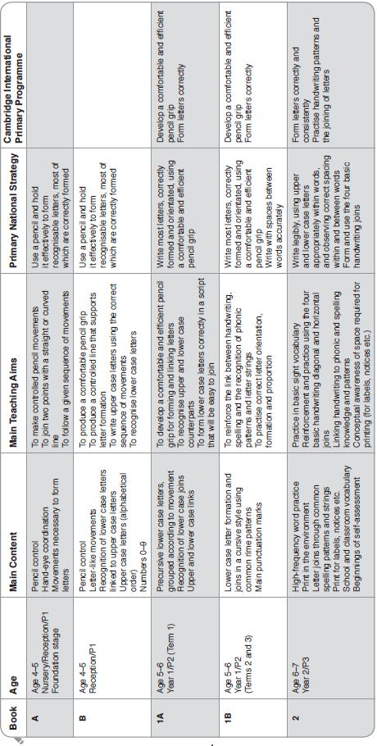
Programme overview
Scottish Curriculum for Excellence
First stage, Writing (Tools for writing): I can present my writing in a way that will make it legible and attractive for my reader (LIT 1-24a)
National Curriculum for Wales
Foundation Stage objective: develop a legible style of handwriting in order to follow the conventions of written English and Welsh
Revised Northern Ireland Curriculum
Key Stage 1 objective: use a legible style of handwriting

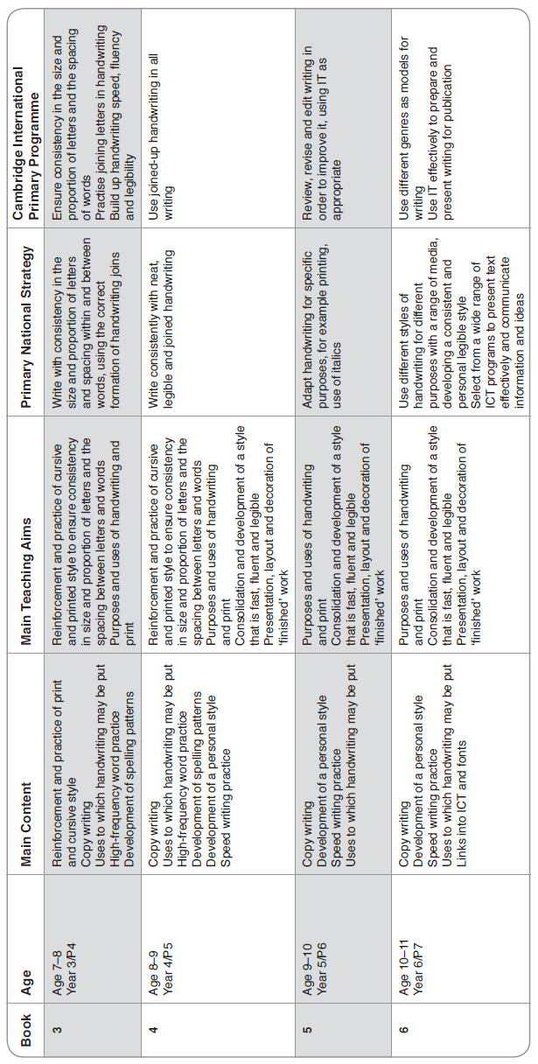
Scottish Curriculum for Excellence
Second stage, Writing (Tools for writing): I consider the impact that layout and presentation will have and can combine lettering, graphics and other features to engage my reader (LIT 2-24a)
National Curriculum for Wales
Key Stage 2 objective: present writing appropriately (develop legible handwriting; using appropriate features of layout and presentation, including ICT)
Revised Northern Ireland Curriculum
Key Stage 2 objective: develop a swift and legible style of handwriting
General introduction

Collins Primary Focus: Handwriting is a comprehensive programme designed to support teachers and children through the stages of learning a clear, fluent, legible and fast style of joined writing from the early stages to the top of the Primary phase. The programme provides copiable material that is intended for use through shared sessions, guided group tuition and individual practice.
Teacher notes
The programme begins with patterns and movements, which will be necessary to improve hand-eye coordination, fine motor control and individual letter production.
Linked to National Curriculum levels and the Primary National Strategy, the programme encourages a precursive and then a cursive style from the early stages of learning.
The programme aims to link the development of handwriting skills and style to the main patterns and rules of the English spelling system. As children practise the movements necessary to make the joins and patterns of the handwriting scheme, they are also reinforcing the patterns of the main onset, rime and spelling patterns.
By Book 2, children are provided with an opportunity to experiment with alternative letter shapes when forming their own personal handwriting style.
Books 3–6 introduce the notion of keeping a handwriting folder containing samples of material that will prove useful when presenting and setting out work for publication. The books include many uses to which both printing and joined handwriting skills may be put.
Books 3–6 also introduce the concept of two types of handwriting: one style may be used for ‘speed’ tasks, e.g. personal note-taking; the other, neater, style may be used for presentational work. Self assessment sheets are included in Book 3 (pp.20 and 63) and Book 6 (p.20). Books 3–6 also link handwriting skills to the basic skills of layout and presentation on a computer keyboard.

The joining of letters in words: which style is most appropriate?
Teachers will always have views about the efficacy or attractiveness of specific letterforms.
It must be remembered that every adult will consider the formation that they use to be the most comfortable to them. However, this does not necessarily make it the most effective formation for children learning for the first time. Teachers must bear in mind the need to develop a handwriting style that is clear, fluent, legible and fast for children learning for the first time.
What about exceptions?
For children with dyspraxia or other handwriting difficulties, the teacher may need to look for SEN support. These children may already be receiving handwriting tuition as part of their support. Children who move schools may well have already learned another handwriting style. If they enter school during the Infant stage, teachers may wish them to recap pages from the previous book, and this may be completed – with the cooperation of parents – as a homework activity. Children who move schools during the Junior stage may well have formed a personal handwriting style, which, although different, is clear, fluent and legible. It may be inappropriate to alter their handwriting style at this stage.
The notes on particular handwriting difficulties (see p.14 of the Teacher notes in Books 1A–2) may also provide useful information.
Letterforms in the programme
Collins Primary Focus: Handwriting aims for the development of joined handwriting as soon as individual precursive letterforms have been mastered. Specific letterforms have been selected to meet the following criteria:
● They should help children’s handwriting to be clear, fluent, legible and fast.
● Each individual lower case letter chosen begins from the main writing line.
● Each lower case letter is taught with both a leadin and a lead-out stroke. This is to help avoid confusion in young children about whether to

begin a letter at the top or the bottom. It has also proved to be beneficial for children with poor hand control and for dyslexic children.
● The joined lower case letters should, where possible, resemble closely their printed counterparts.
● Letters, such as ‘s’ should have the same form wherever they occur in a word, thus reducing the amount that children need to relearn.
● It is possible to join all lower case letters. One letter (‘f’) changes from the precursive to the cursive stage. While it is felt that the ‘f’ used in Book B will be familiar to young children learning to form the precursive letters, the cursive ‘f’ is used from Book 1A to encourage a more fluent hand.
● The pencil or pen should need to be lifted from the page as little as possible when linking lower case letters in words, thus reinforcing the patterning of joined movements within letter strings as an aid to memorising phonic and spelling patterns.
Precursive Upright (Book B)
Cursive Upright (Books 1A–1B)
Cursive Slanted (Books 2–6 )
The following letter styles have been chosen to meet the preceding list of criteria:
Specifi c letter style options
The reasoning behind each cursive letter style option chosen for use in Collins Primary Focus: Handwriting was discussed with several Literacy and SpLD (Dyslexic) practitioners who agreed with the choices.
 | Chosen because, looped from the back, it is easiest to link to all other letters, always joining the same way and thus more fluent.
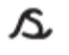 | Chosen because it joins in the same way whether it is at the beginning, in the middle or at the end of a word, thus making it fluent and meaning there is less for children to learn.
 | Chosen because it is more legible, most like the printed ‘v’ and less likely to be confused with the letter ‘u’.
 | Chosen because it is more legible, most like the printed ‘w’ and less likely to be confused with the letter ‘u’.
 | This is the only small letter that requires the pencil/pen to be lifted from the paper. This style was chosen because it will join and because it is most like its precursive counterpart.  A curved ‘x’ can often be confused for the letters ‘sc’; this is particularly so for dyslexic and less able readers.
 | Chosen because it is more legible, most like the printed ‘y’ and doesn’t involve taking the pencil/pen off the paper.
 | Chosen because it will join and because it is most like its precursive counterpart.
As children move on to join letters in words, they will learn that many letters will join in different places, depending on the letter they are linked to. The programme aims to support the development
of strong links between the formation of patterns
in handwriting and those involved in phonic and
spelling knowledge.
Contents of the programme
Infant Stage
Book A: Foundation Stage and Reception/P1
This book introduces the fine motor movements and pencil control that will be necessary for the formation of letters and patterns. It provides practice in moving from left to right, keeping within ‘tramlines’ and making the up-and-down and curved movements necessary for letter formation.
Book B: Reception/P1
This book reinforces movements and patterns which will help children to make the movements they will need when learning to form letter shapes. For many children the movements from left to right and from top to bottom may not be intuitive, hence the instruction to ‘Start at the ✩.’
Practice is also provided in each of the movements for upper case letters. These have been placed early in the programme because many children will have learned at least some of these letters before they begin formal schooling, and so any inappropriate movements can be corrected early.
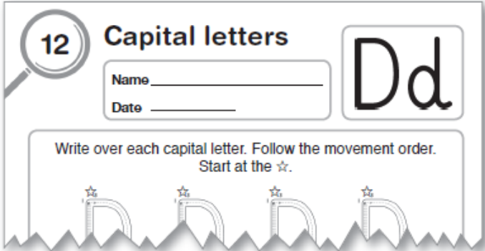
Book 1A: Year 1/P2 (Term 1)
Linked closely to the National Curriculum and Primary National Strategy, this book provides more intense teaching strategies and practice for the first term of formal tuition.
Since it is at this stage that children may learn incorrect or inappropriate movements, each individual letter shape and movement is taught with a lead-in and a lead-out stroke beginning from the writing line. The letters are grouped according to the main movements involved so that children gain extra reinforcement of the shapes and movements involved. By grouping letters according to their movement, it is also hoped to avoid the confusion that many children encounter between letters that may look very similar in print, e.g. ‘b’ and ‘d’, ‘p’ and ‘q’, ‘n’ and ‘h’.
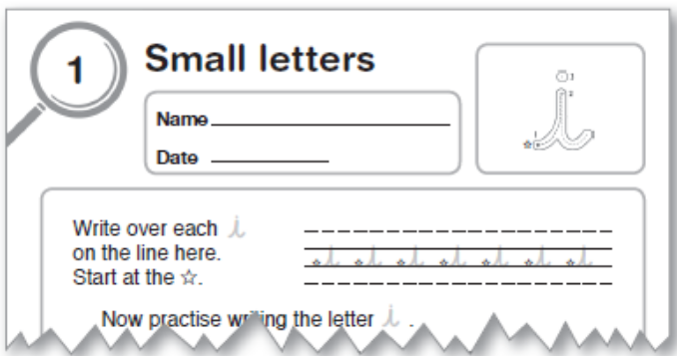
Book 1B: Year 1/P2 (Terms 2 and 3)
To provide extra practice in the transition from precursive to cursive letters, an extra book has been included at this stage. In this book, upper
case letters and lower case letters are reinforced through some of the main rime patterns that will be used for spelling. In this way the development of a cursive hand is linked to the introduction of spelling patterns.
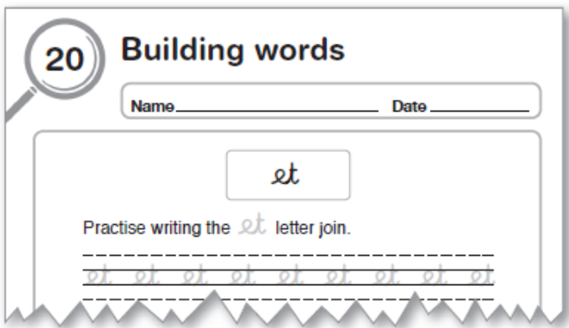
Book 2: Year 2/P3
This book continues the development of linking handwriting to spelling, introducing joins through the main onset groups and blends and the highfrequency words required to be learned and practised by the end of the Infant stage.
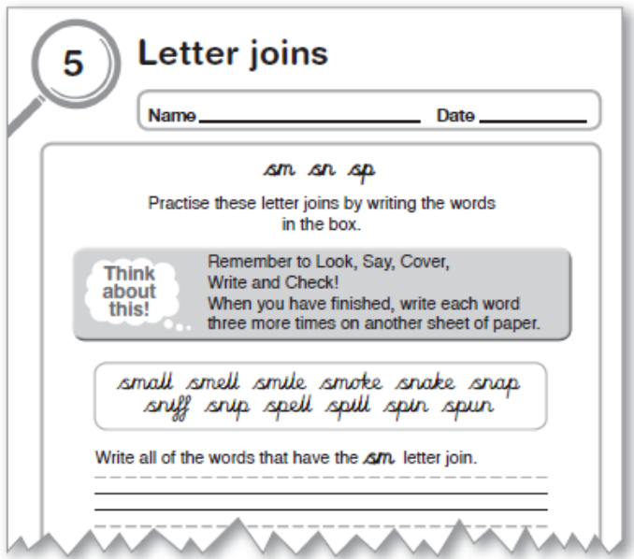

Junior Stage
Book 3: Year 3/P4
This book reinforces the handwriting style already learned, through sentences, spelling patterns and simple tongue-twisters and rhymes. During this book, children are encouraged to attempt writing with their eyes closed to help fix the pattern of movements in the mind. (It may be helpful if teachers show children how to place their pencil or pen on the writing line before closing their eyes!)
Through this book, children are introduced to the idea of collating a handwriting folder. Some tasks will need to be completed on another sheet of paper. This book also contains ideas for exemplar material to be retained by children in their handwriting folder.
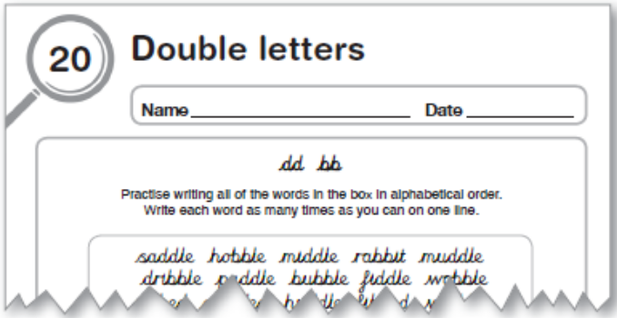
Book 4: Year 4/P5
At this stage, children are encouraged to examine different handwriting purposes and styles. This book also includes settings in which print letters may be appropriate both in upper case and lower case forms.
Links with common spelling rules and patterns and common high and medium-frequency vocabulary are continued. This book also introduces practice in writing at speed.
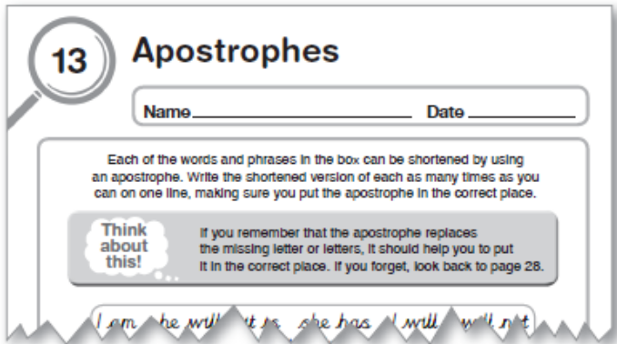
Book 5: Year 5/P6
Throughout this book, children explore different contexts in which a well-formed handwriting style plays an important part. They are asked to use both print and joined styles to transform material from
a range of curricula and everyday situations for presentation to others. By this stage, children will be developing at least three handwriting styles:
● A neat, ‘best’ form for presentational work that may be produced slowly and with care. This style may be part of a ‘school style’.
● A speedier and sometimes less neat form for, e.g. making personal notes or copying work to be presented later. It is perfectly reasonable that some children using this style may begin to ‘personalise’ their writing. They may begin to add loops or serifs, adopt alternative letterforms and link upper case letters to lower case letters – as many adults do. They may also experiment with a unique signature at the foot of their work. This personalisation should be encouraged as long as it fits the criteria of being clear, fluent, legible and fast.
● A clear, well-formed print style for labels, notices, captions etc. demonstrating judgement about style, size, and spatial awareness of the room available.
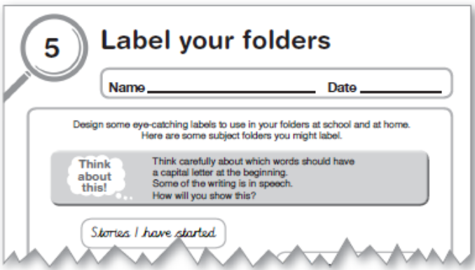
Book 6: Year 6/P7
This book extends children’s mastery of the three forms of handwriting listed in the Book 5 entry on this page. Children are encouraged, through a variety of traditional calligraphy and modern presentational tasks, to develop a style that is personal and unique to themselves.
(The relationship between hand-crafted and computer-aided design is extended.)
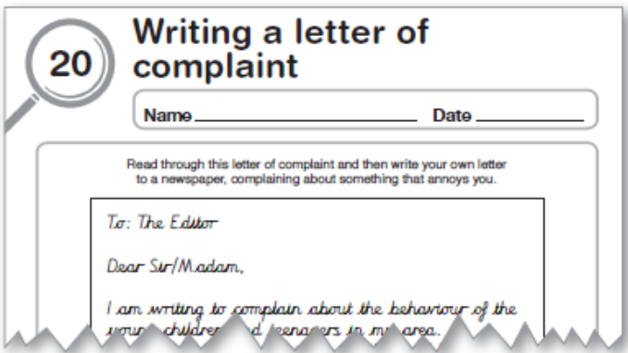

Moving from Book A to Book B
Some of the prerequisites for good handwriting are:
● To establish early learning goals for future letter formation and handwriting.
● To link sounds to letters, naming and sounding the letters of the alphabet.
● To know that print carries meaning and, in English, is read (and written) from left to right and top to bottom.
● To attempt writing for various purposes, using features of different forms such as lists, stories, instructions.
● To write their own names and other things such as labels and captions and begin to form simple sentences, sometimes using punctuation.
● To use a pencil and hold it effectively to form recognisable letters, most of which are correctly formed.
Source: Early Learning goals – Language and Literacy (DfEE)
The Foundation stage in handwriting needs to provide:
● Opportunities for children to hear, use, see and read familiar words.
● Opportunities to link sounds to letters.
● Opportunities to see adults writing, and for children to write for themselves.
In the early stages of practice in handwriting, children have four main requirements:
● They need space to try out, on a grand scale, the movements and patterns that will become letter-like movements.

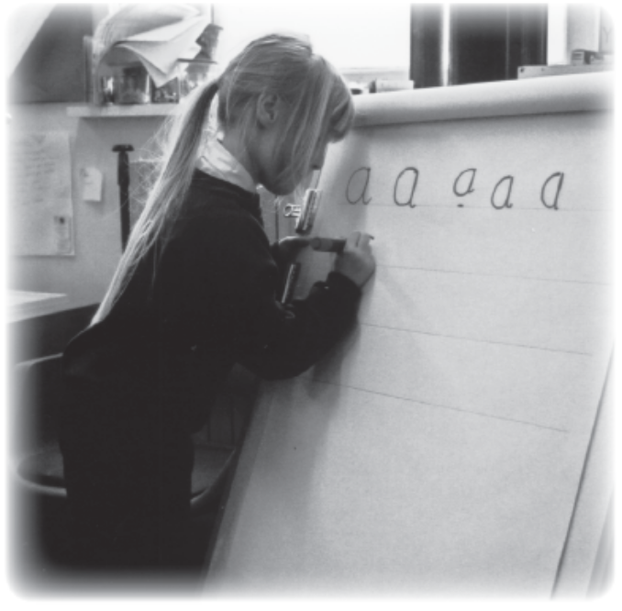
● They need to use, in play, the same kind of movements and patterns that they will need to hold a pencil, to make straight and curved movements, and to fulfil a pattern or sequence in the correct way across a page.
● They need to see models of writing and the purposes to which writing will be put and to attempt them for themselves.
● They need to be encouraged to ‘have a go’, confident that they will be praised for what is right rather than criticised for what is wrong.
Many children will still need the forms of pre-handwriting play outlined in Book A.
While play activities continue, teachers and assistants will need to monitor several aspects of children’s readiness for formal tuition. By Book B, children will need to learn some of the essential habits for good handwriting.
Which hand?
Many children at the Foundation Stage may not have firmly established the dominance of a writing hand. While many of us are ambidextrous to a certain extent, all of us have a dominant hand for writing; and because this is also linked to the cerebral hemispheres of the brain, it should be detected as early as possible. The practice of ‘forcing’ right-handed writing is now, thankfully, largely defunct, but play activities can be crucial in helping a child to reinforce the dominance that is natural to them.
Large movements, such as ball-play, can help teachers in detecting which hand is likely to be more dominant. One initial indicator is the foot that children use to a) kick a ball or b) make the first movement when climbing. The foot is less likely to have been influenced by outside factors such as parents or carers using a particular hand for feeding or cleaning teeth etc. For this reason, it is often a key indicator of the dominant side of the hemisphere. It is preferable, unless physical disabilities preclude it, for children to use the same side as their writing hand. A child with very strong dominance of one side will rely more on their right foot, hand and eye. A child with mixed dominance is more likely to suffer from at least mild learning difficulties in terms of handwriting. Likewise, crosslaterality, i.e. having a different dominant eye and hand, can cause difficulties in terms of pencil control and the orientation and spacing of letters. While these conditions cannot always be avoided, they can at least be noted.

Pencil/pen control
The pencil or pen should be gripped loosely between the first finger and thumb, using the second finger as a rest. The non-writing hand should be used to support and guide the paper. Many children do not learn this automatically, and it may need to be specifically taught.
Children may, even at a very early age, have learned an inappropriate grip. In some cases the hand may curl right over the pencil or pen, making their writing look extremely awkward. Teachers need to make several judgements before intervening to alter such a grip:
● If the child suffers from even a minor manual difficulty, the grip used may be the most comfortable to them.
● If their handwriting is clear, fluent, reasonably legible (to themselves and other children!) and reasonably fast, attempting to change their grip may do more harm than good. These children would benefit from the same practice in patterning and fluency as those with cramped or jerky hand movements. Tips on detecting and correcting difficulties can be found on pp.13–15 of the Teacher notes in Books 3 and 4.
● If altering the grip is the only solution, these children may benefit from recapping of earlier books in the programme as homework practice or with SEN support sessions, to help them relearn the correct movements.
Setting up a special handwriting table makes it easier to make pencil grips or triangular-shaped pencils or pens available for those children who find them more comfortable to use. Several suppliers make triangular-shaped pencils, which children may find more comfortable than a pencil grip.
If the layout of the classroom precludes or hinders the setting-up of a handwriting table, children should be taught where their particular handwriting aids are kept and trained to find them for themselves before beginning their handwriting lesson. Information about these implements and aids should also be made readily available to all staff members.

Activities to aid the development of handedness and pencil control
While many children may not yet be able to use one hand to catch a ball or a bean-bag, they are likely to use their dominant hand to throw it. Foundation setting assistants can also be alerted to take notice of which hand a child uses, for example, to stir, or beat imaginary eggs when making a cake; to pick up coloured sticks or art straws; to balance blocks in a pile; to beat a drum and to feed fish.
It may be necessary to keep and maintain a record for some children over a period of time and across a full range of activities before a final decision about a dominant hand is reached. Parents may also be consulted to keep a similar record at home. This type of record may also be useful in detecting any dyspraxic difficulties, or clumsiness in fine motor movements, in order to provide more directed support.
Once it has been established which hand the child prefers to use, the use of it can be strengthened by offering toys, tools or implements towards that hand.
Threading large beads can help to strengthen hand-eye coordination. Weaving paper strips or art straws, or making collage pictures by gluing material or objects to paper, will also help.
Using a computer mouse and keyboard, particularly those adapted for use by young children, can also help in the development of hand-eye coordination and control of movements. It is even more helpful if the computer mouse can be sited for use by either hand.
Knowledge of upper case letters
Before they enter a Foundation setting, many children learn the rudiments of writing at home. When they do so they will often print their writing in upper case letters. This is particularly so when learning to write their name. It should also be borne in mind that because many upper case letters are formed from the joining of straight ‘stick’ shapes, they may be easier to learn at first than the more curvy lower case letters. In the environment of print around them, children will also see much evidence of printed upper case writing in road and street signs, advertisements, shops, packaging etc.
Rather than try to undo these early handwriting attempts, Collins Primary Focus: Handwriting attempts to build on them by initial practice and reinforcement of upper case letters. This also allows the children to continue with their own unaided writing, using printed upper case letters if they wish, without feeling that they are in error.
It is important, however, that children extend their
early knowledge by linking each upper case letter
to its lower case equivalent.
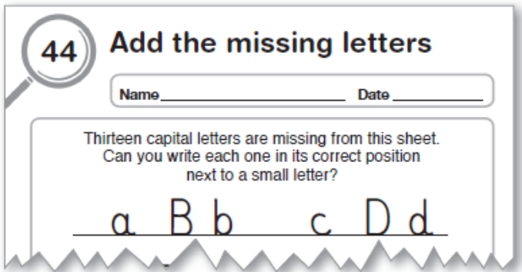
It is helpful if children can also see upper case letters in posters and signs around the classroom, so that they become familiar with their use.

Points to remember when teaching handwriting
Seating
The seating of children for handwriting lessons is particularly important. For this reason, some teachers prefer to specify a ‘handwriting table’, where the light is particularly good and shines from the side or back of the children.
Many children find it more comfortable to slant their work to the side, away from their writing hand, so that they can clearly see what they are writing. For this reason, they may need more room for handwriting practice than may normally be available.
Left-handed children will need to be seated at the left-hand side of the table or desk. These children might also need a cushion or pad to provide extra height and may often benefit from a sloping surface, which might be provided by using a ringbinder file, on which to rest their paper.
Pencils and pens
Teachers often feel that providing special handwriting pens for lessons and practice encourages children to take more care with their work. It is now possible to provide a range of rollerball and felt-tip pens that are less likely to leak onto a child’s hands or clothes. Many teachers feel that ‘biros’ are unsuitable because they can easily be smudged, particularly by the left-handed writer whose hand moves across their work.
It is likely, in the main, that children will write in pencil. Teachers may wish to keep some ‘special’ pencils with other handwriting materials. These pencils should be of reasonable length (lefthanders may require a slightly higher grip than their right-handed peers). A range of pencils of differing hardness will also allow children to make judgements about which is the most suitable for them. Pencils should be sharp, but not so sharp that the point breaks on use. Some triangular or wedge-shaped pencils may be included for those who need them. Several suppliers make triangular-shaped pencils that children may find more comfortable than a grip.
Paper
It is also helpful for children to use different types of paper for writing. A box on the handwriting table might contain paper of different textures, quality, colours and shapes for children to present their sample or test pieces. Preprinted sheets with decorative borders might also be used for display or presentation.
Lined or unlined paper
For Books B–2, teachers may wish each child to have their own handwriting book with staved lines for extra practice. This will also provide additional opportunity to reinforce the onset, rime and spelling patterns plus reinforcement of high-frequency words.
Books 3-6 encourage the use of a handwriting folder for which children may use the copiable pages themselves or separate pieces of paper that are then stored in the folder.
It should be remembered that lines spaced too far apart can be as cumbersome as lines spaced too close together. The final page of Books 1A–6 (p.64) is a set of copiable guidelines. These have been deliberately varied throughout the scheme to provide the optimum type for children with particular handwriting difficulties.
For example:
Books 1A–2
_ _ _ _ _ _ _ _ _ _ _ _ _ _ _ _ _ _ _ _ _ _ _ _ __
______________________________________
______________________________________
_ _ _ _ _ _ _ _ _ _ _ _ _ _ _ _ _ _ _ _ _ _ _ _ __

Books 3–6
______________________________________
______________________________________
______________________________________
______________________________________

While many teachers prefer to use unlined paper for everyday work with younger children, Collins Primary Focus: Handwriting provides sets of lines (p.64) for practice. As children gain confidence, they may prefer to use a sheet of unlined paper with a set of guidelines placed underneath it.

Patterns and patterning
Very often an adult, unsure of the spelling of a specific word, will write it several times. It may seem that this is in order to view the ‘look’ of the word; to ‘see’ if it looks right. There is, however, a second element in this trial. Through long experience, our writing hand and fingers also tell us that the sequence of letters ‘feels’ right. Experienced computer keyboard users, who are able not to look at the keyboard as they type, will often know that they have made an error, even before they see it on screen, because the sequence of movements ‘feels’ wrong. Some of the vital knowledge about the writing and spelling of words is held as much by the hands as by the eyes or the brain. We literally have the knowledge about patterns and sequences in words that we write regularly, at our fingertips.
Every teacher of Junior age children will, at some stage, have come across children who seem not to have developed this facility to ‘feel’ whether a word is correctly written or not. They may, incidentally, be the very same children who find it hard to detect a rhyme in words, or who, having spelled ‘cat’ correctly, cannot spell ‘catch’. Much of the foundation for this knowledge is laid down in the early years of learning, and it can be aided by activities that develop the concept of a pattern.
Vocalising the patterns of movement
Work on patterns may begin with reasonably large objects such as blocks or three-dimensional shapes. Children may begin by matching a given pattern, e.g. car, lorry, bus, car, lorry, bus; red block, green block, blue block, red block, green block, blue block. Physically moving items to make the patterns helps to involve the hands and provides vital thinking time to work out the correct sequence.
As the teacher makes the patterns, it is helpful if they talk their way through it, e.g. ‘First I am putting a red block, then a green block, then a blue block.’ The children should be encouraged to sing along, joining in with the pattern. Vocalising the pattern in this way aids the memory and brings another sense into play.
Once children have grasped the concept of a repeated pattern, they might begin to make similar patterns on paper, initially with finger-paint and then with coloured crayons or pencils. Teachers or teaching assistants might make linked patterns in sand or on paper for children to go over, again first with the finger and then with a writing implement.
One of the first personal patterns children need to grasp is that which forms their own first name. By repeating their first name in different sizes and colours all over a piece of paper, children begin to grasp the idea of repeating the same thing over and over again. They also gain vital practice in writing their first name correctly.
Examples of patterns in wallpaper, material, hair ribbons etc. might be displayed in the writing area, so that children may trace over the patterns with their fingers before attempting to replicate some of the patterns in paint or crayon.

The writing environment
All of us use both print and joined writing for different purposes. Work in Europe has shown that children are easily able to distinguish between the two if they are used to seeing them. The instructions in the Collins Primary Focus: Handwriting books are written in printed script to distinguish them from writing the children will copy. It is helpful if children see signs and posters around the classroom in both printed and joined styles, to help them make judgements about the appropriateness of each for particular situations. As they gain confidence, children will take great pride in producing some of these signs, notices and labels for themselves.
It is also helpful for children to see the upper case and lower case alphabets in the selected letter styles, displayed close to where they write. Children should be encouraged to contribute to the classroom display by copying out class rules, tips for better writing etc. As they learn them, they might also make posters of grammatical definitions, spelling rules or useful proverbs and sayings etc.
If display space permits, examples from children’s handwriting may be specially mounted and displayed in the writing area. Where space is at a premium, children might mount ‘best’ examples of their handwriting in a Big Book anthology.
Before writing
Organisation and timing of lessons
Teachers may use Collins Primary Focus: Handwriting as part of a Literacy lesson or as a separate lesson. The programme has been designed for use by a guided group who will then continue on to complete the sheets independent of teacher support. (Children with particular difficulties may work with the support of a teaching assistant.)
Some teachers may prefer to work through particular pages with the whole class before children move into groups to complete the tasks. Pages marked in the notes on p.16 are considered most suitable for this. Most pages are copiable and have a self-assessment box at the foot of the page that allows the child to decide, in cooperation with the teacher, whether to move on or repeat the task for reinforcement or practice.
Ideally, children should practise their handwriting on a daily basis, and to facilitate this, teachers may decide to work through the content of a particular sheet in a guided group session, once a week, so that children may be observed as they practise in their own Handwriting folders. The children might then complete the sheet independently in the following days

Book B
Foundation Stage
Book B begins with some additional practice in hand-eye coordination and the correct directional movements for letter formation. It continues through the precursive letters, both upper case and lower case.
Upper case letters are taught first, since these should act as reinforcement for many children who may have learned them before they entered school. Some children, of course, may be encountering them for the first time and this provides an opportunity to reinforce correct directional movement and order.
Lower case letters are introduced in groups of three and two, each linked to their upper case counterpart.
Teachers should note particularly that the style of the letter ‘f’ used in Book B is in a precursive style and will change in Book 1A in order to facilitate a more fluent join.
The final pages of the book provide practice in the numbers 0–9; while the number-rhyme on the final page also provides an opportunity to draw children’s attention to common punctuation marks.

Page 17
Teachers may wish to use this page in a shared session to establish some of the conventions of the book. They may wish to introduce the phrase ‘Start at the ✩.’, which helps children to know where to begin. The arrows and numbers showing direction and order of movement should also be pointed out. Read out the instruction and check that children understand the task.
Encourage children to use an appropriate grip and to move from left to right, and from the top to the bottom of the page.
In Collins Primary Focus: Handwriting, children are asked to sign their name and put the date at the top of the page, which may be a new step for them. It is expected at this stage that children will use their normal style for this. Dating their work may help teachers when assessing children’s progress.
The task might be introduced to the class through a shared session, asking children to complete the sheet as part of their guided group work. Alternatively, each page might be introduced as part of guided group work for children to complete independently.
Encourage children to vocalise the movements as
they make them.
Pages 18–24: Pencil control and hand-eye coordination
Once teachers are confident that children can work independently, these pages might be completed in independent group activities.
Pages 25–50: Upper case alphabet sequence
Although many children will have learned to write in upper case letters before school or earlier in the Foundation Stage, sometimes they will have learned inappropriate movements, e.g. beginning from the bottom or making straight lines from right to left. This block of 26 pages allows for relearning in the correct form. Children then use the upper case letters to make names beginning with each letter.
Pages 51–59
These pages introduce the lower case letter shapes, which will be used in Collins Primary Focus: Handwriting, in alphabetical order. At this stage, children are asked to form the unjoined letters, linking them to their upper case counterparts so that they may follow their sequence. (In Book 1A, lower case letters will be reintroduced in groups that have a similar order of movement in preparation for joining.)
Teachers may wish to introduce the first page through a guided group session.
Pages 60–61
These pages link upper case letters with their lower case counterparts by asking children to complete the alphabet. The pages may be used as ‘sampler’ or check pages for upper case and lower case letters. Children should be encouraged to sound the letters as they write and to check back to relevant pages if they are unsure of the movements.
Page 62–63
These pages introduce the numbers 0–9.
Page 64
A number-rhyme to copy. This page also includes
some of the main punctuation marks that children
will need to learn and use in their writing.



Practising patterns

Name ____________________________ Date _____________

Draw over the dashes to complete these
straight-line patterns. Start at the .

Brilliant!  OK  I need another try.
How did
you do?

www.collinseducation.com © HarperCollinsPublishers Limited 2011


Look out below!

Name ____________________________ Date _____________

The three parachutists are about to land. Join the dashes
to show the direction each will take to land right on
the target. Start at the .

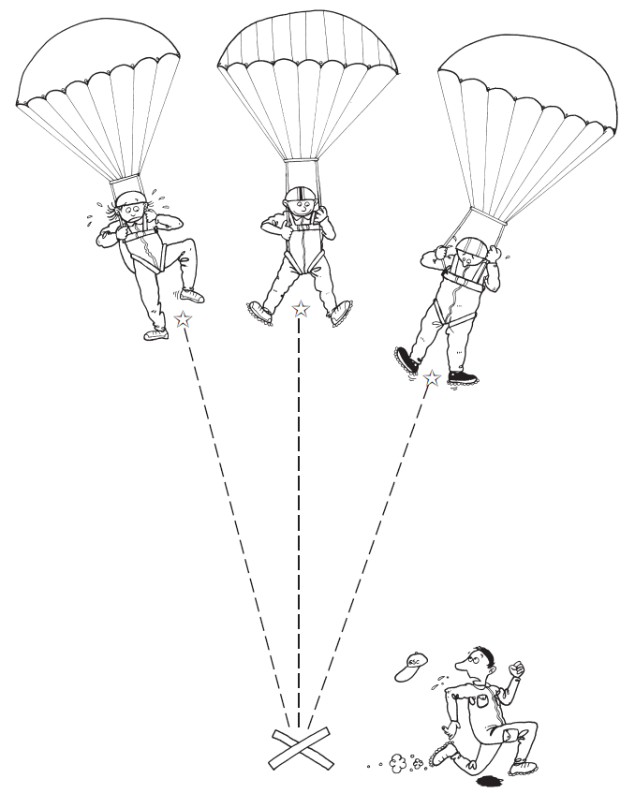
How did
you do?
Brilliant! OK I need another try.

www.collinseducation.com © HarperCollinsPublishers Limited 2011




Time for lunch

Name ____________________________ Date _____________

Mother bird has caught a worm for her hungry chicks.
But the worm is big and heavy, so Mother bird must fly
from branch to branch or she will get tired. Join the dashes
to show her flight from the top of the tree down to the nest.
Start at the .

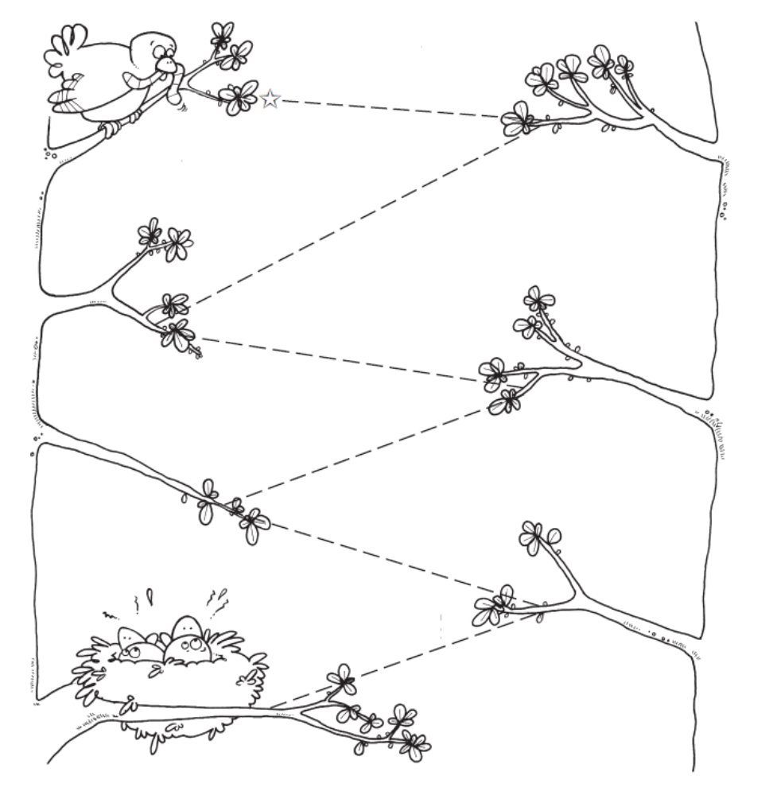

How did
you do?
Brilliant! OK I need another try.

www.collinseducation.com © HarperCollinsPublishers Limited 2011



Name ____________________________ Date _____________
Practising patterns

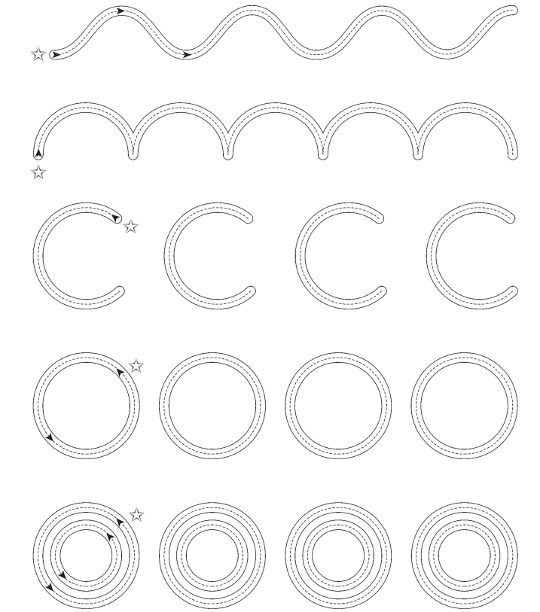
Draw over the dashes to complete these
curved-line patterns. Start at the .
How did
you do?
Brilliant! OK I need another try.

www.collinseducation.com © HarperCollinsPublishers Limited 2011
Name ________________________________ Date __________________


Mice on the run!

The five hungry mice have found some food, but their little
front door has been locked by one of the cats.
Join the dashes in the five lines to show how the mice are
trying to escape. Start at the .

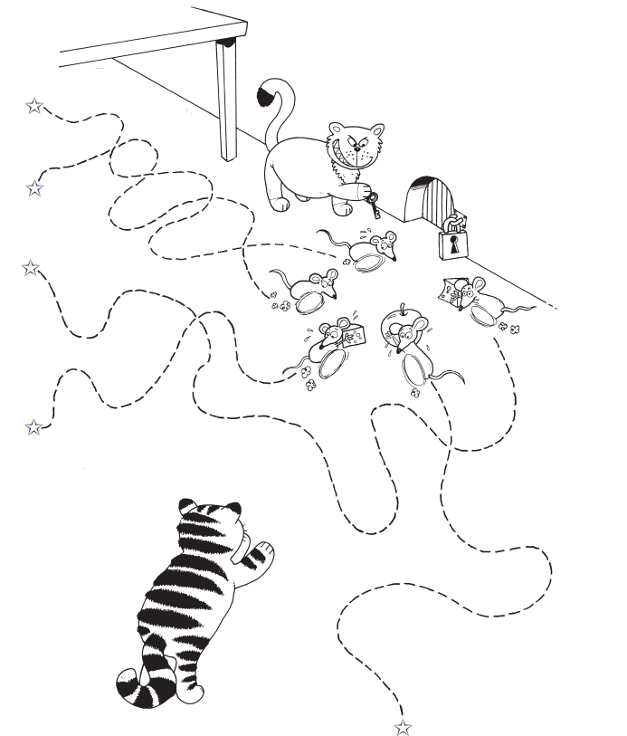

Brilliant! OK I need another try.
How did
you do?

www.collinseducation.com © HarperCollinsPublishers Limited 2011
Name ____________________________ Date _____________
Here comes the water!



Bill the gardener uses water from a hosepipe to water his
flowers, while Sam the fireman uses water from a bigger
hosepipe to put out a fire. Join the dashes to show the way
water comes out of each hosepipe and falls on to
the flowers and the fire. Start at the .

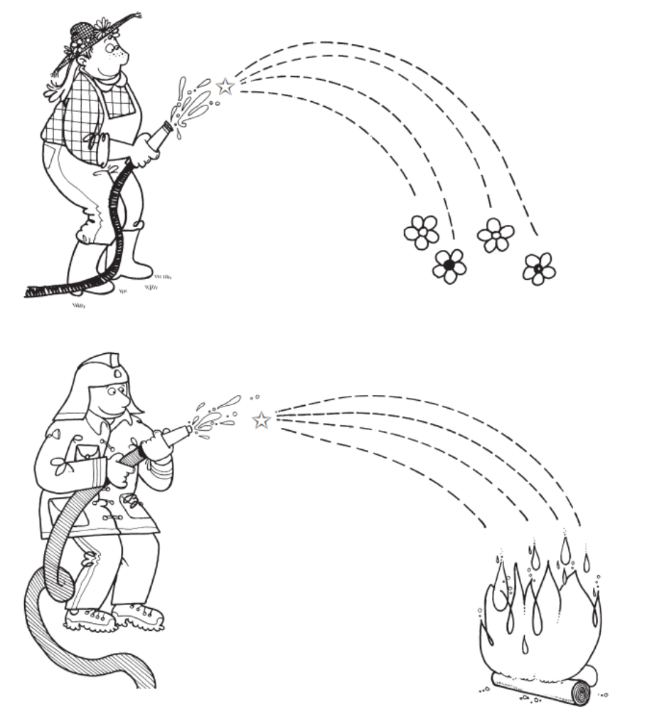
How did
you do?
Brilliant! OK I need another try.

www.collinseducation.com © HarperCollinsPublishers Limited 2011



One jump ahead

Name ____________________________ Date _____________

Kangaroos are very good at jumping over things,
but this one has something in its pouch to help it jump over
a high fence. Join the dashes to show how the kangaroo
jumps up and over the wall and fence. Start at the .
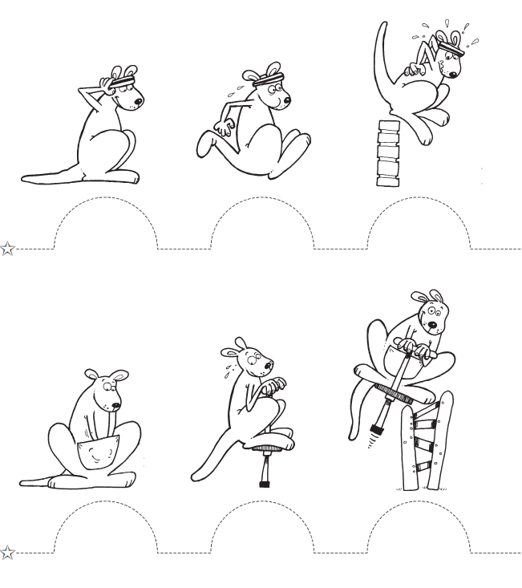

Brilliant! OK I need another try.
How did
you do?

www.collinseducation.com © HarperCollinsPublishers Limited 2011



On the ball

Name ____________________________ Date _____________

Jugglers and seals use different-sized balls
to entertain the crowds. Join the dashes to make four
juggling balls and one beach ball. Join the dashes inside
the beach ball to make a pattern of circles, then colour
them with crayons or felt-tip pens.

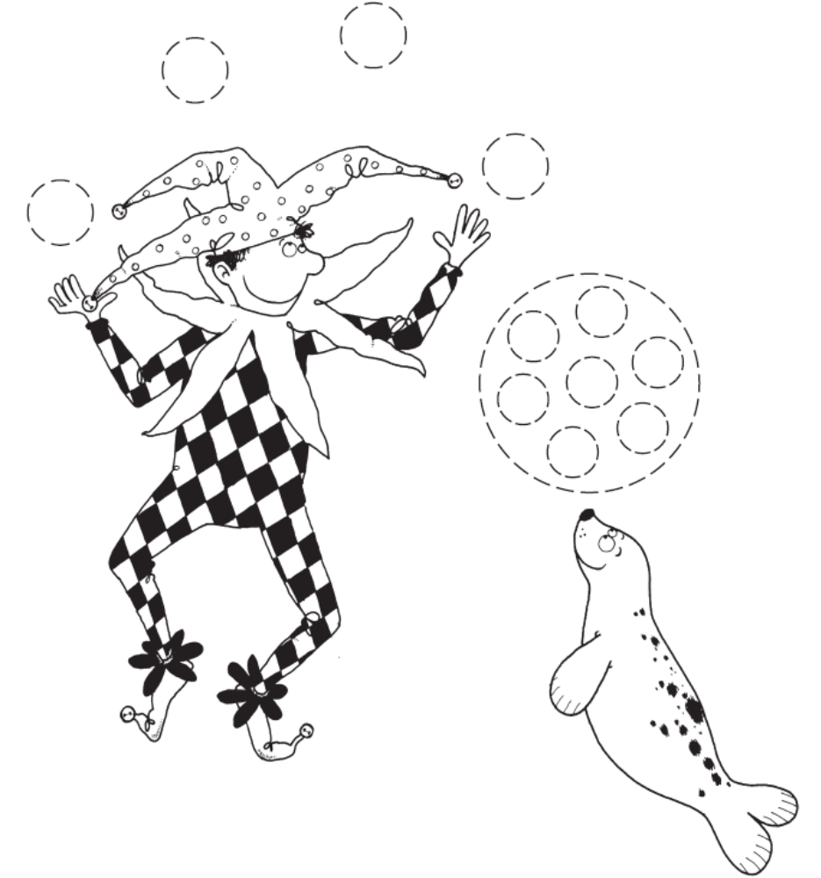
How did
you do?
Brilliant! OK I need another try.

www.collinseducation.com © HarperCollinsPublishers Limited 2011


Capital letters

Name ________________________

Date _____________

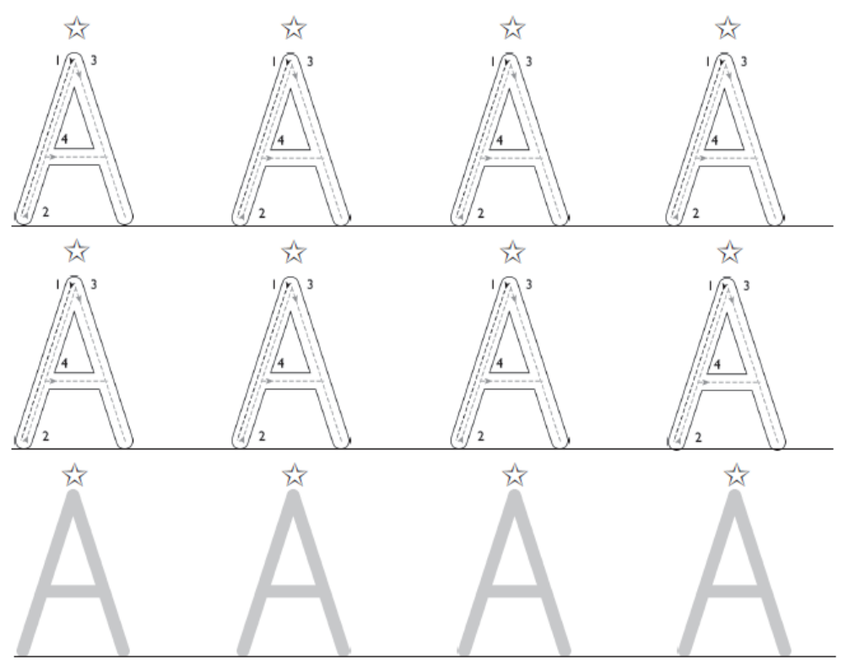
Write over each capital letter. Follow the movement order.
Start at the .
Write over the capital letter in these names.
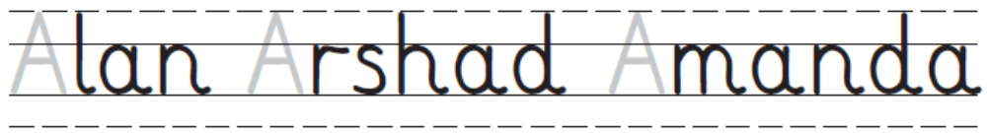
Now add the capital letter to the names.
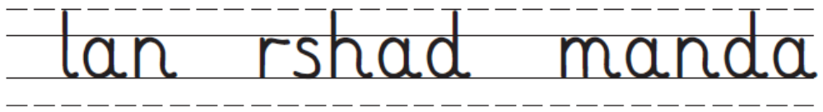
How did
you do?
Brilliant! OK I need another try.

www.collinseducation.com © HarperCollinsPublishers Limited 2011
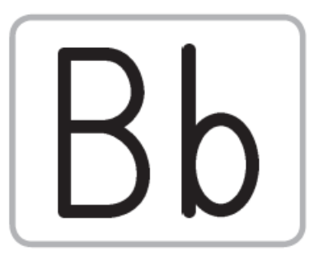

Capital letters

Name __________________________

Date _____________

Write over each capital letter. Follow the movement order.
Start at the .
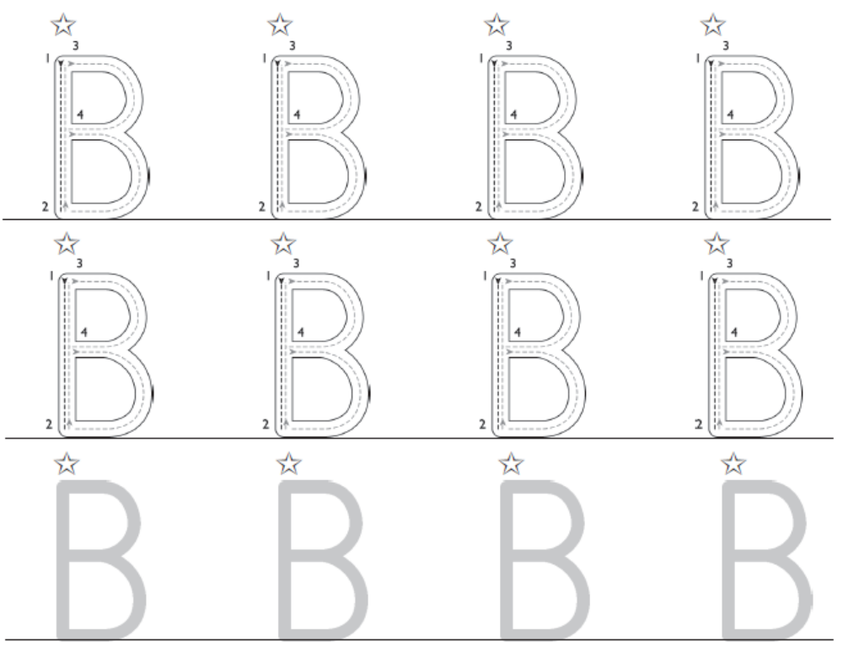

Write over the capital letter in these names.
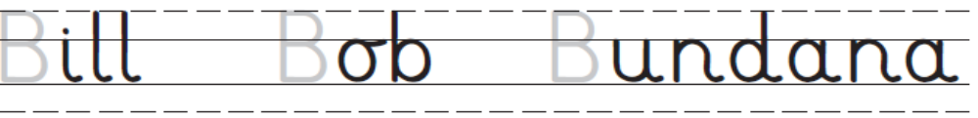

Now add the capital letter to the names.
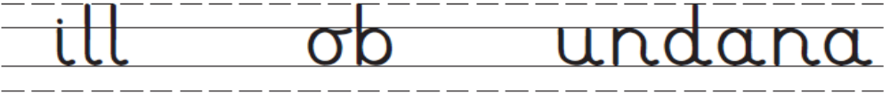
Brilliant! OK I need another try.
How did
you do?

www.collinseducation.com © HarperCollinsPublishers Limited 2011




Capital letters

Name __________________________

Date _____________

Write over each capital letter. Follow the movement order.
Start at the .
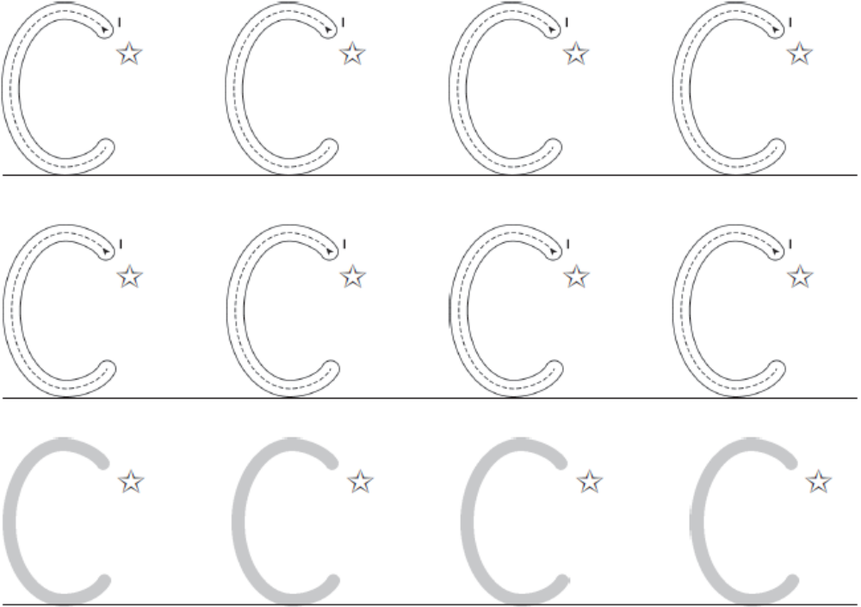

Write over the capital letter in these names.

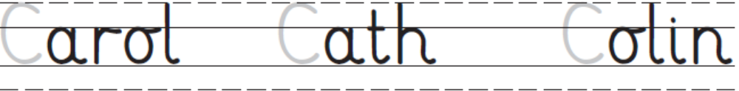

Now add the capital letter to the names.

How did
you do?
Brilliant! OK I need another try.

www.collinseducation.com © HarperCollinsPublishers Limited 2011

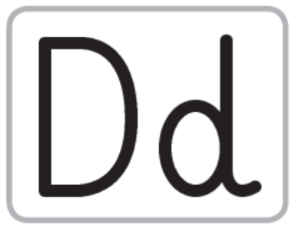

Capital letters

Name __________________________

Date _____________

Write over each capital letter. Follow the movement order.
Start at the .
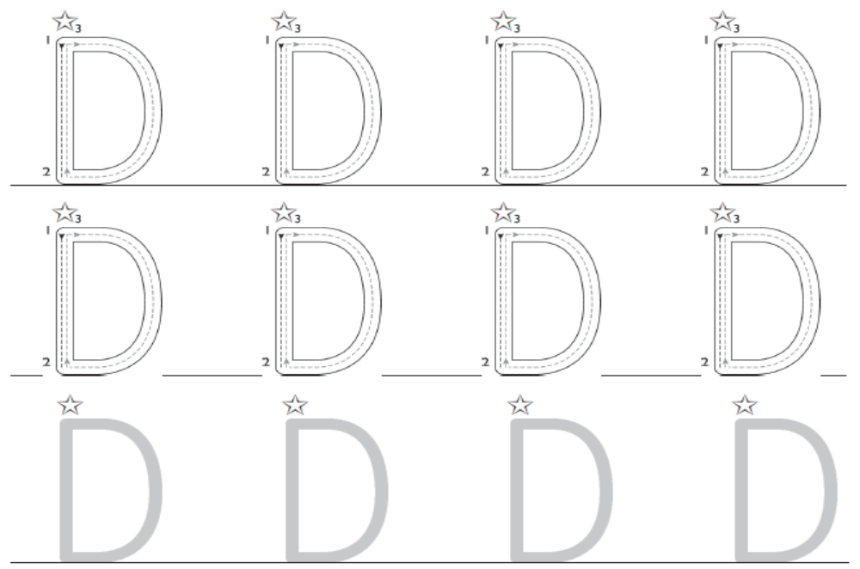

Write over the capital letter in these names.
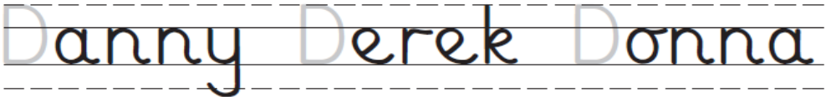

Now add the capital letter to the names.
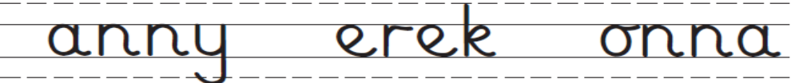

How did
you do?
Brilliant! OK I need another try.

www.collinseducation.com © HarperCollinsPublishers Limited 2011



Capital letters

Name ___________________________

Date _____________

Write over each capital letter. Follow the movement order.
Start at the .

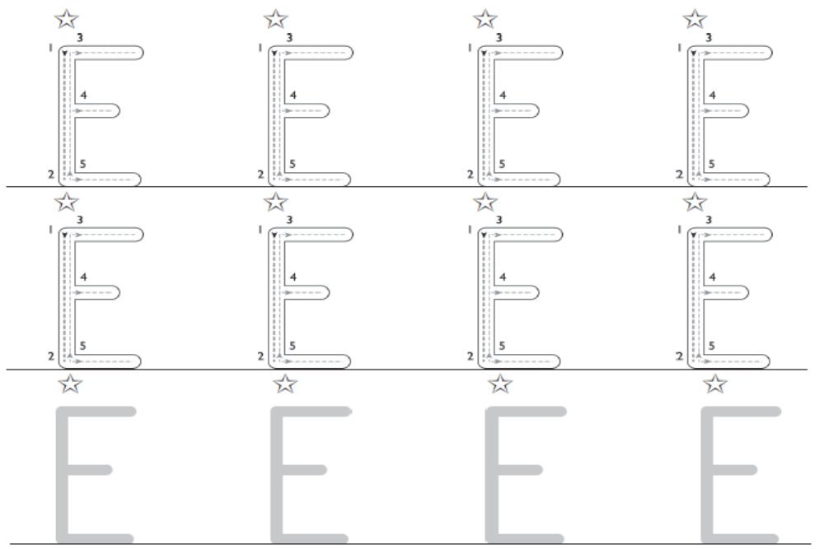

Write over the capital letter in these names.

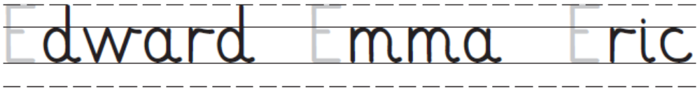

Now add the capital letter to the names.
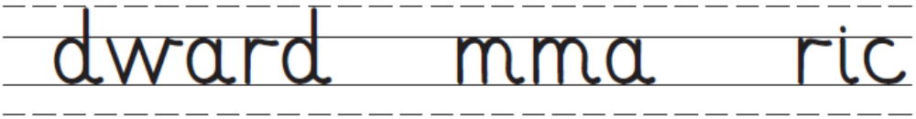

How did
you do?
Brilliant! OK I need another try.

www.collinseducation.com © HarperCollinsPublishers Limited 2011



Capital letters

Name ___________________________

Date _____________

Write over each capital letter. Follow the movement order.
Start at the .
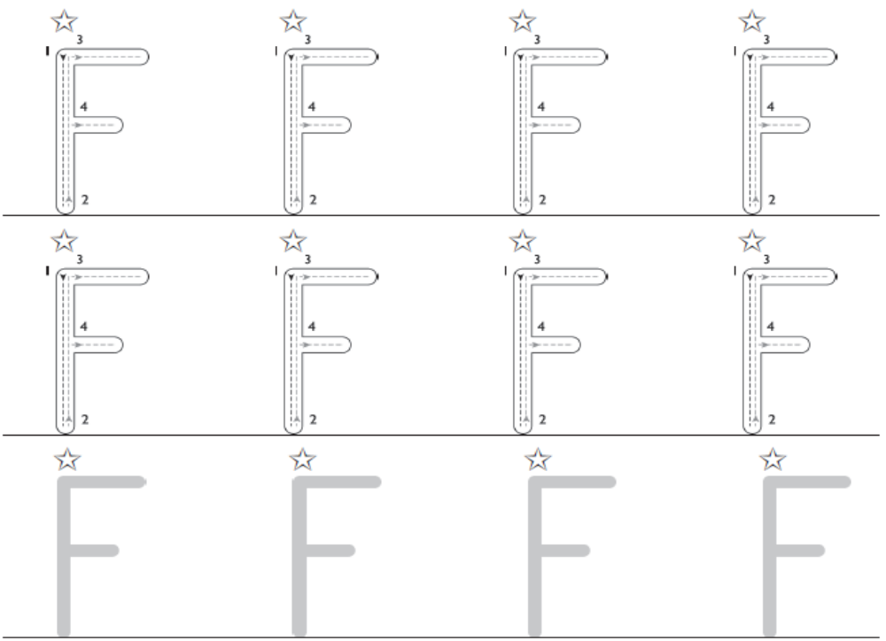

Write over the capital letter in these names.
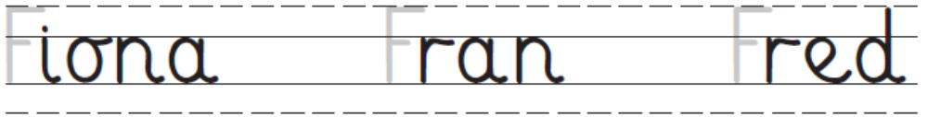

Now add the capital letter to the names
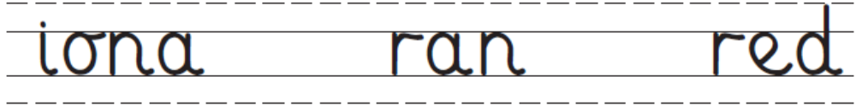

Brilliant! OK I need another try.
How did
you do?

www.collinseducation.com © HarperCollinsPublishers Limited 2011


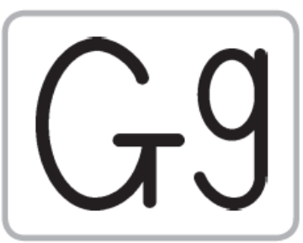

Capital letters

Name ___________________________

Date _____________

Write over each capital letter. Follow the movement order.
Start at the .
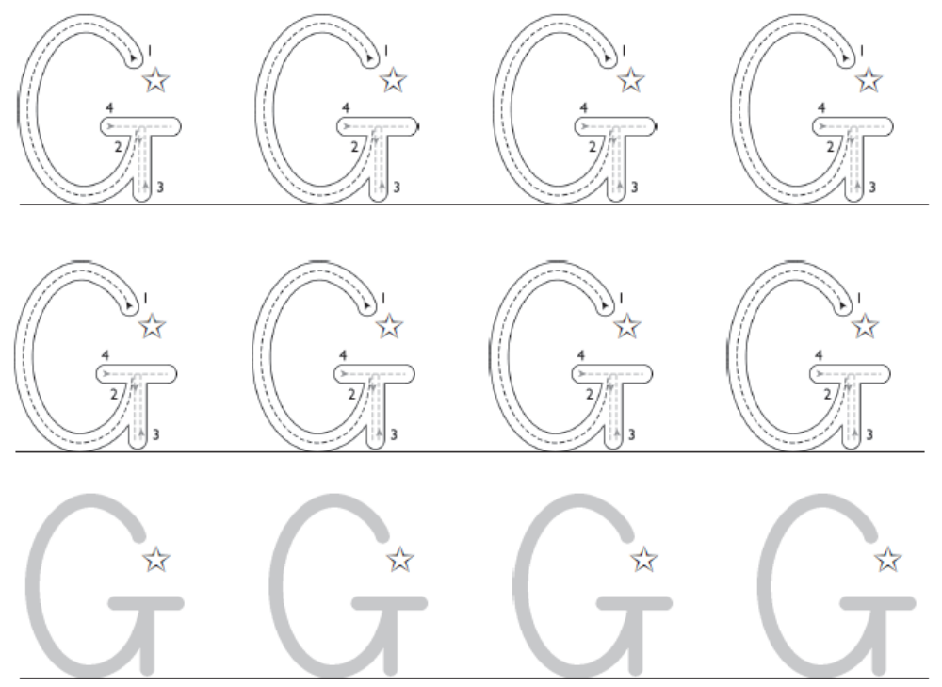

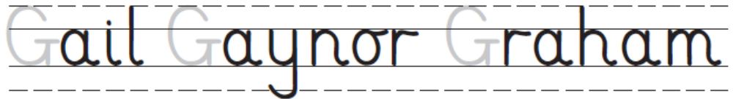
Write over the capital letter in these names.

Now add the capital letter to the names.
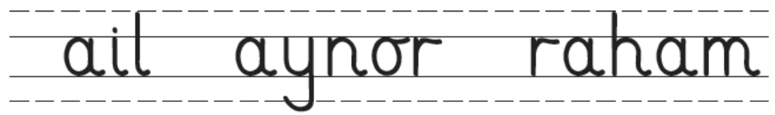

Brilliant! OK I need another try.
How did
you do?

www.collinseducation.com © HarperCollinsPublishers Limited 2011
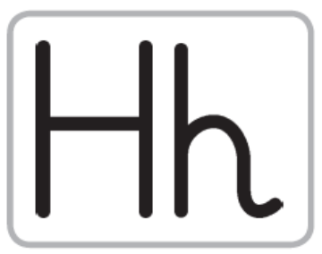


Capital letters

Name ___________________________

Date _____________

Write over each capital letter. Follow the movement order.
Start at the .
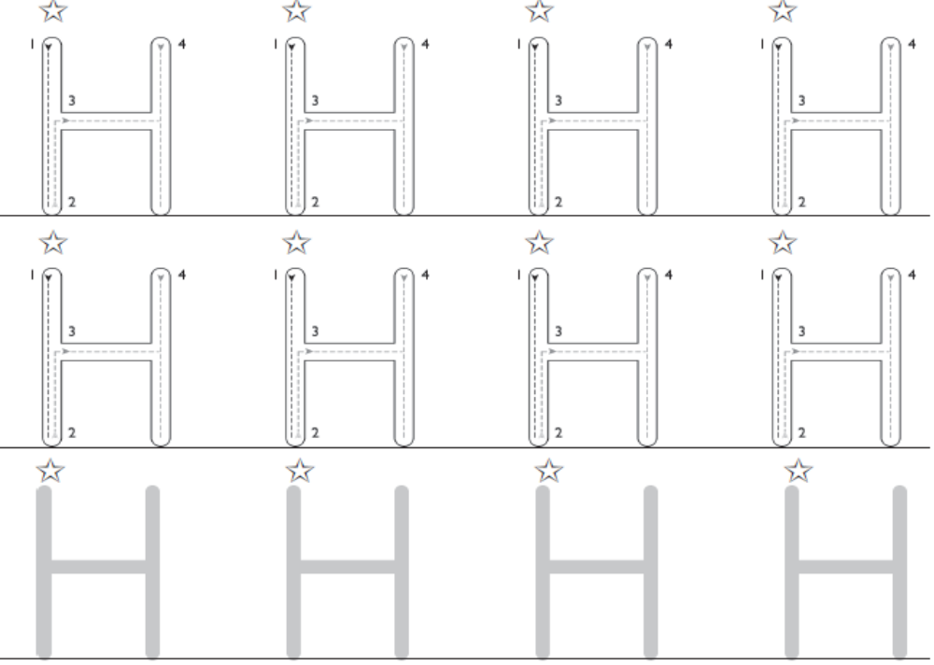

Write over the capital letter in these names.

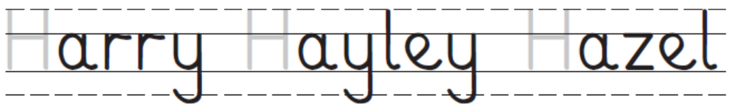

Now add the capital letter to the names.
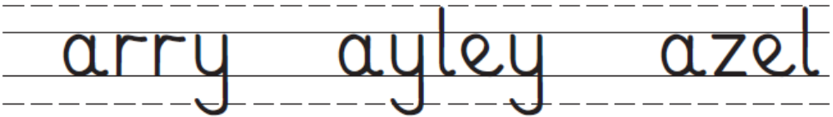

How did
you do?
Brilliant! OK I need another try.

www.collinseducation.com © HarperCollinsPublishers Limited 2011

Capital letters

Name ___________________________

Date _____________

Write over each capital letter. Follow the movement order.
Start at the .

Write over the capital letter in these names.

Now add the capital letter to the names.
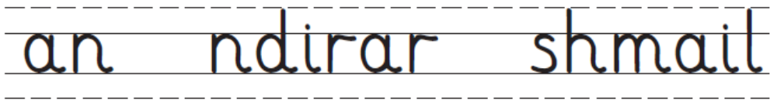

How did
you do?
Brilliant! OK I need another try.

www.collinseducation.com © HarperCollinsPublishers Limited 2011


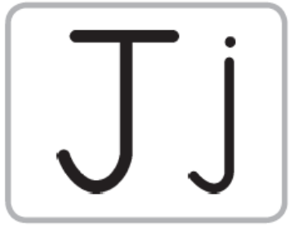

Capital letters

Name ___________________________

Date _____________

Write over each capital letter. Follow the movement order.
Start at the .
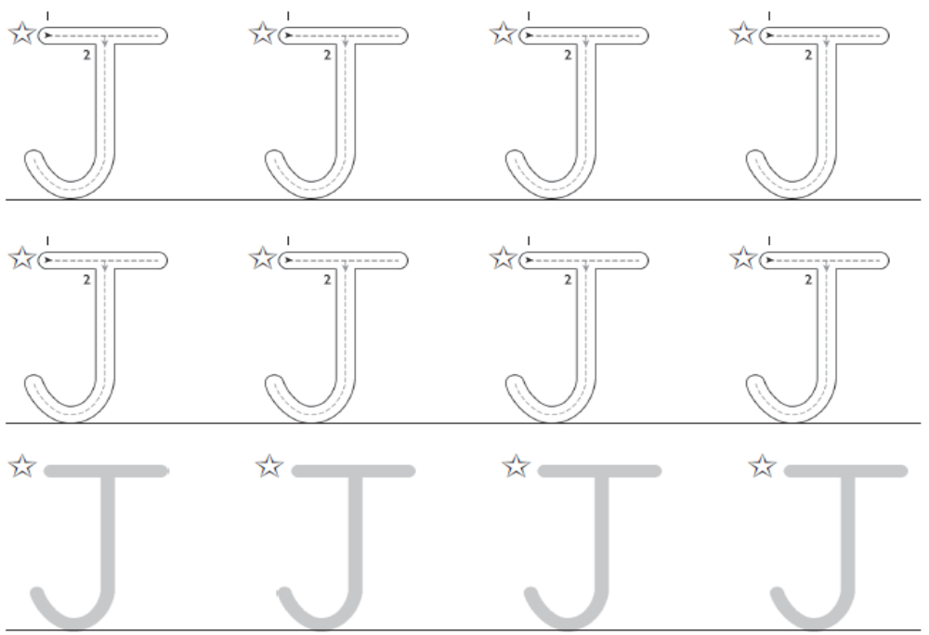

Write over the capital letter in these names.
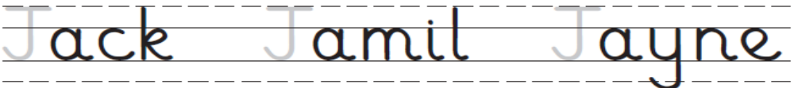

Now add the capital letter to the names.
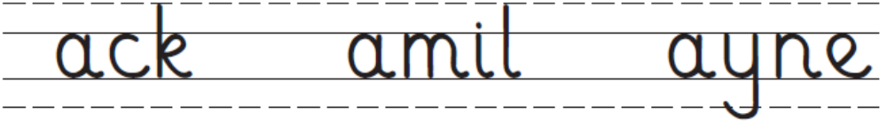

Brilliant! OK I need another try.
How did
you do?

www.collinseducation.com © HarperCollinsPublishers Limited 2011

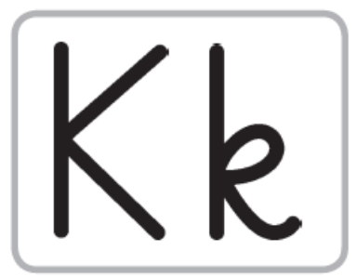

Capital letters

Name ___________________________

Date _____________

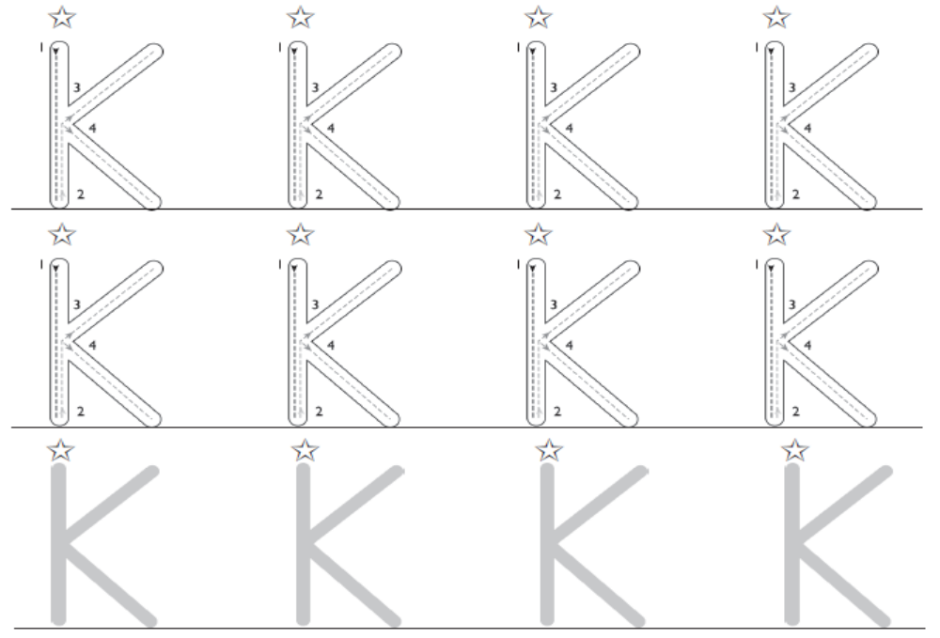
Write over each capital letter. Follow the movement order.
Start at the .

Write over the capital letter in these names.
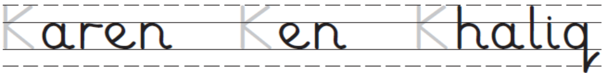

Now add the capital letter to the names.
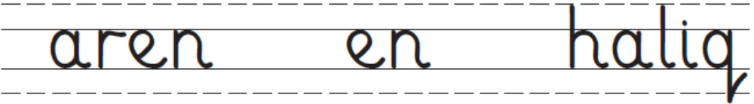
Brilliant! OK I need another try.
How did
you do?

www.collinseducation.com © HarperCollinsPublishers Limited 2011




Capital letters

Name ___________________________

Date _____________

Write over each capital letter. Follow the movement order.
Start at the .
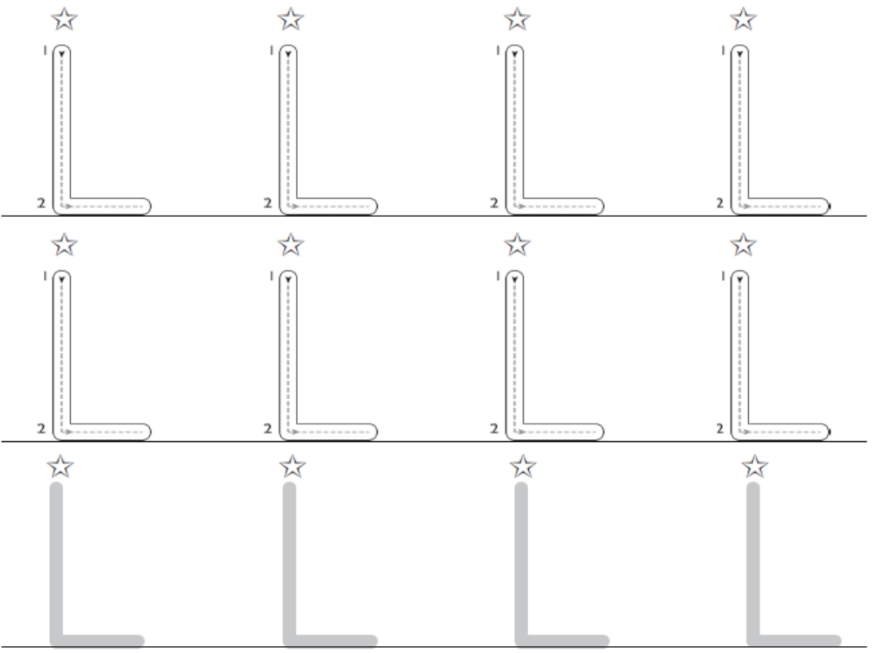

Write over the capital letter in these names.
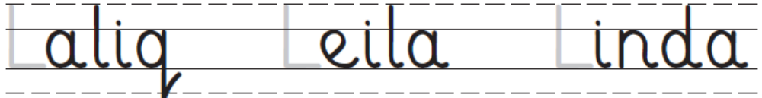

Now add the capital letter to the names.
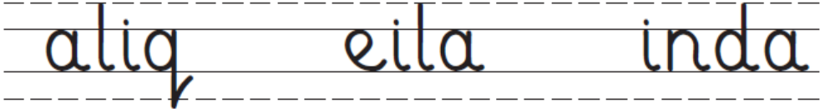

How did
you do?
Brilliant! OK I need another try.

www.collinseducation.com © HarperCollinsPublishers Limited 2011


Capital letters

Name ___________________________

Date _____________

Write over each capital letter. Follow the movement order.
Start at the .

Write over the capital letter in these names.

Now add the capital letter to the names.
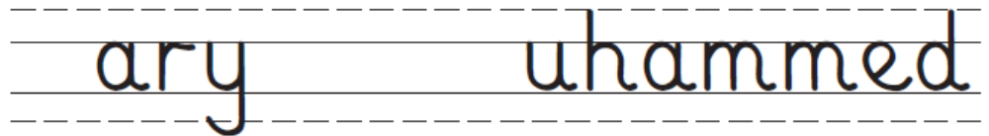
Brilliant! OK I need another try.
How did
you do?

www.collinseducation.com © HarperCollinsPublishers Limited 2011




Capital letters

Name ___________________________

Date _____________

Write over each capital letter. Follow the movement order.
Start at the .

Write over the capital letter in these names.

Now add the capital letter to the names.


How did
you do?
Brilliant! OK I need another try.

www.collinseducation.com © HarperCollinsPublishers Limited 2011
Capital letters

Name ___________________________

Date _____________

Write over each capital letter. Follow the movement order.
Start at the .
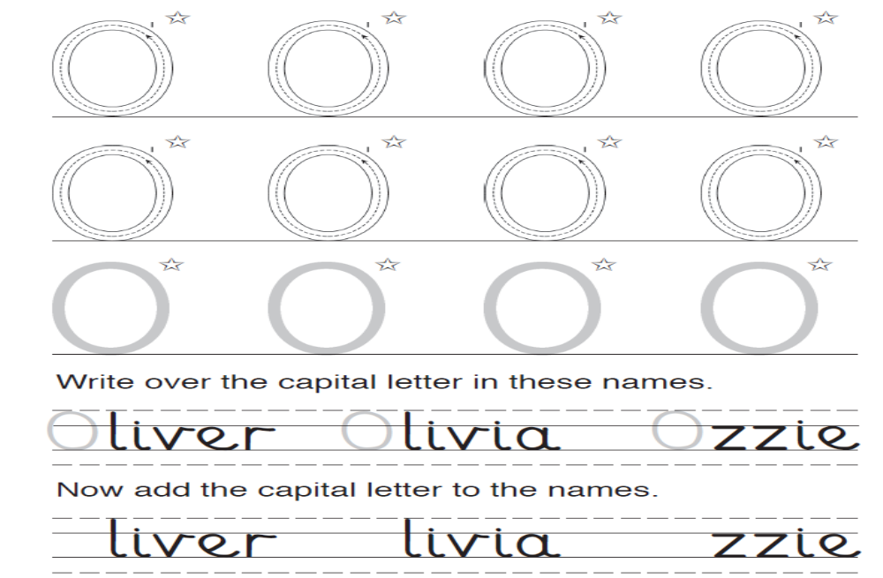

Write over the capital letter in these names.

Now add the capital letter to the names.
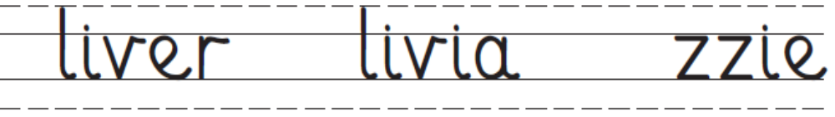

How did
you do?
Brilliant! OK I need another try.

www.collinseducation.com © HarperCollinsPublishers Limited 2011




Capital letters

Name ___________________________

Date _____________

Write over each capital letter. Follow the movement order.
Start at the .
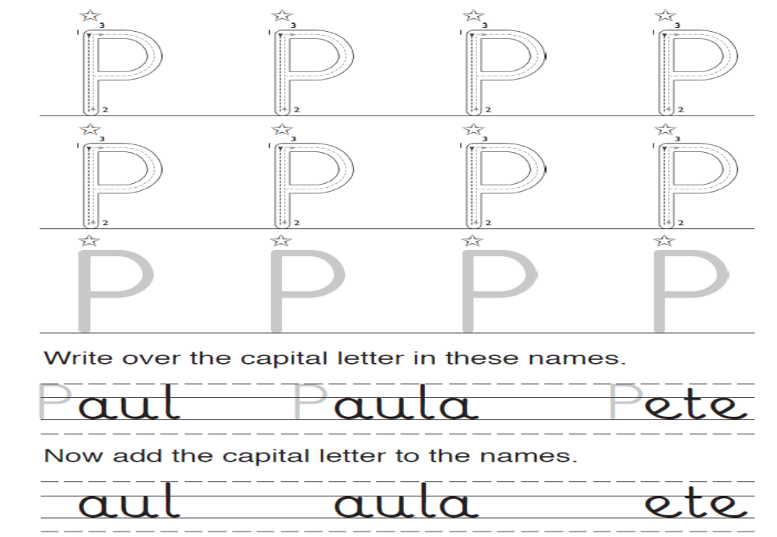

Write over the capital letter in these names.
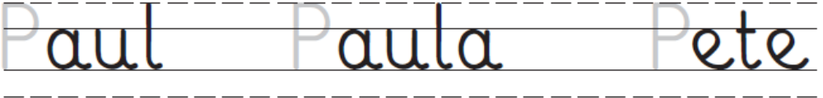

Now add the capital letter to the names.

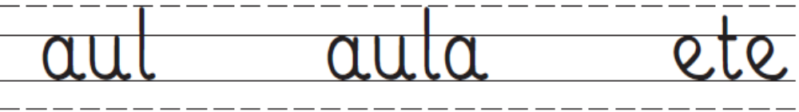

How did
you do?
Brilliant! OK I need another try.

www.collinseducation.com © HarperCollinsPublishers Limited 2011

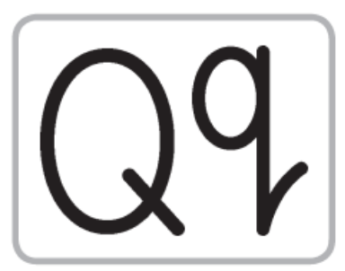



Capital letters

Name ___________________________

Date _____________

Write over each capital letter. Follow the movement order.
Start at the .
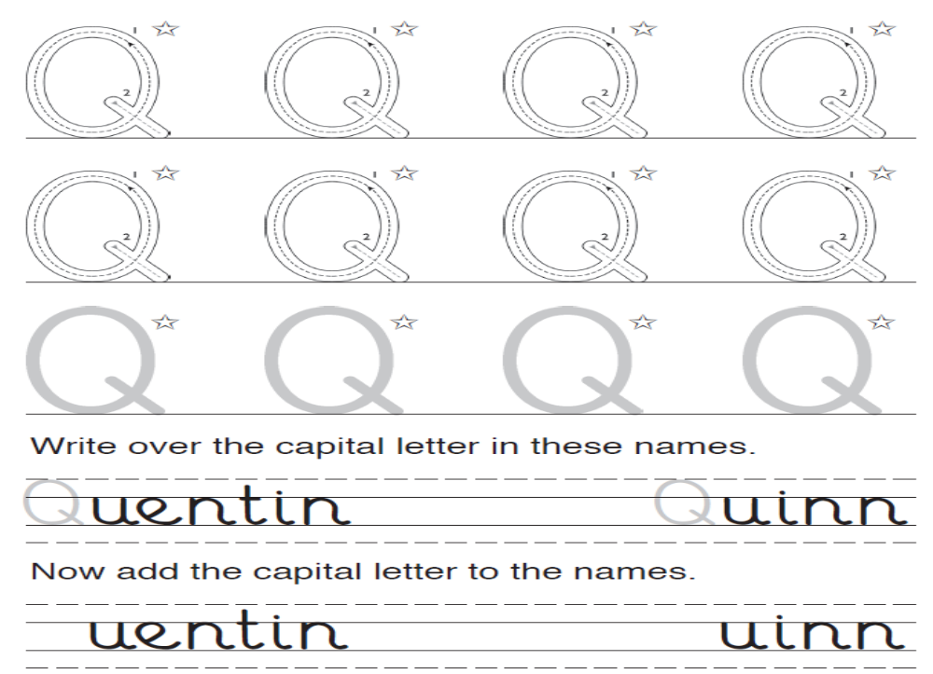

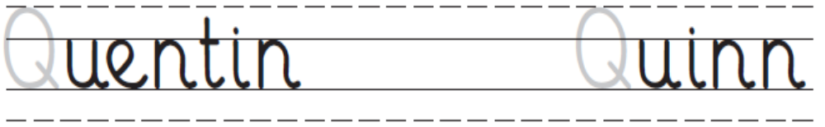
Write over the capital letter in these names.

Now add the capital letter to the names.
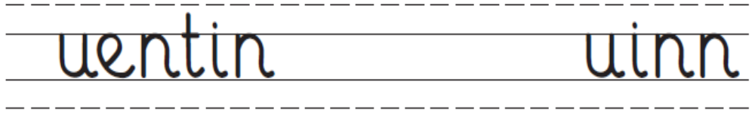

How did
you do?
Brilliant! OK I need another try.

www.collinseducation.com © HarperCollinsPublishers Limited 2011



Capital letters

Name ___________________________

Date _____________

Write over each capital letter. Follow the movement order.
Start at the .
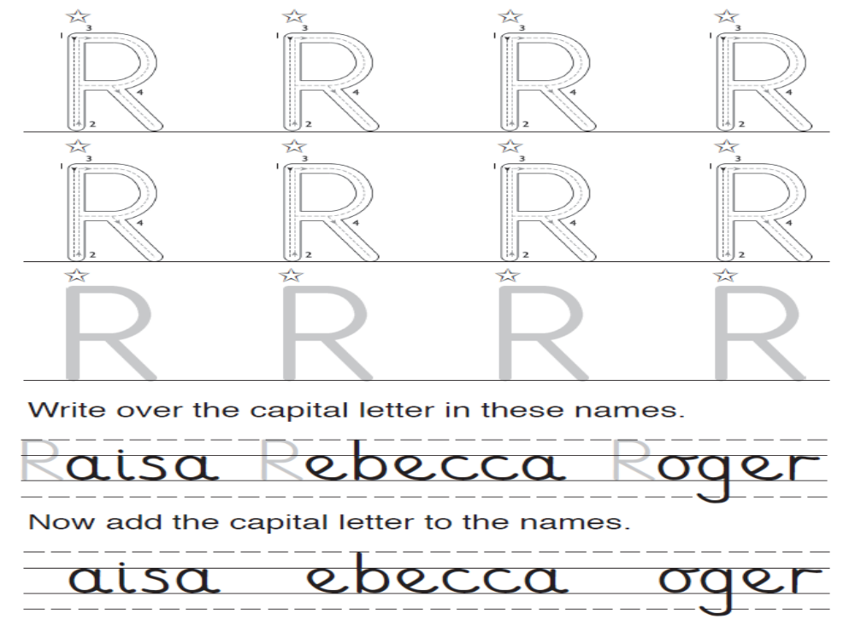

Write over the capital letter in these names.

Now add the capital letter to the names.
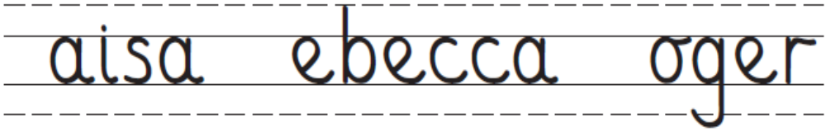

How did
you do?
Brilliant! OK I need another try.

www.collinseducation.com © HarperCollinsPublishers Limited 2011




Capital letters

Name ___________________________

Date _____________

Write over each capital letter. Follow the movement order.
Start at the .
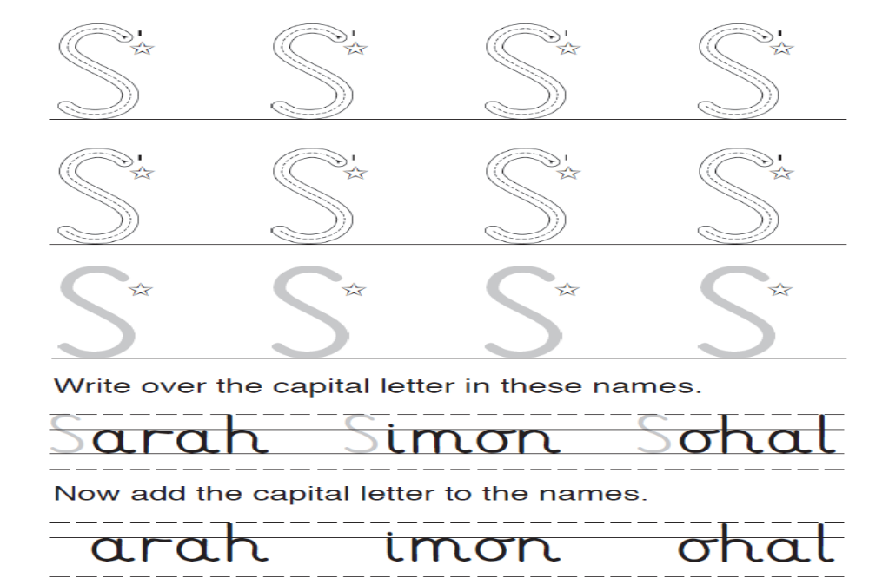

Write over the capital letter in these names.
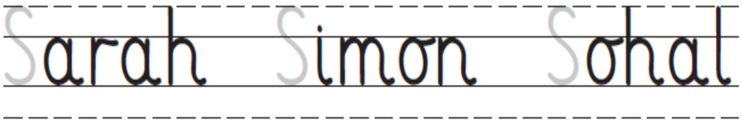

Now add the capital letter to the names.
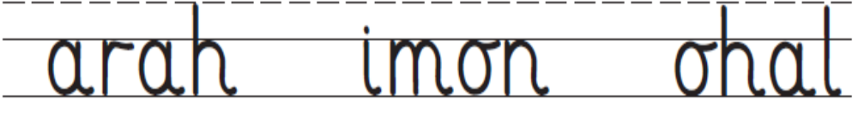

How did
you do?
Brilliant! OK I need another try.

www.collinseducation.com © HarperCollinsPublishers Limited 2011




Capital letters

Name ___________________________

Date _____________

Write over each capital letter. Follow the movement order.
Start at the .
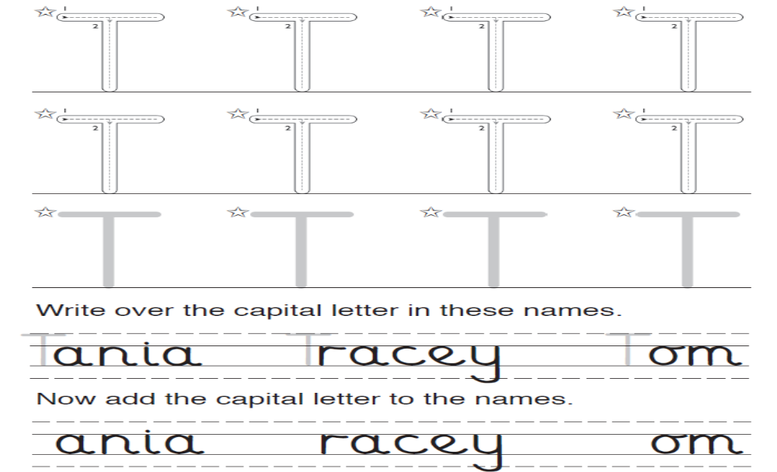

Write over the capital letter in these names.
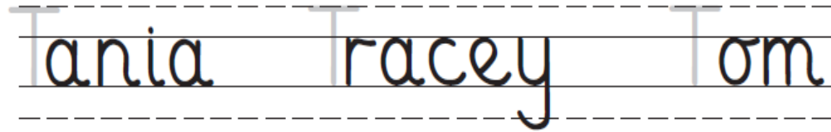
Now add the capital letter to the names.
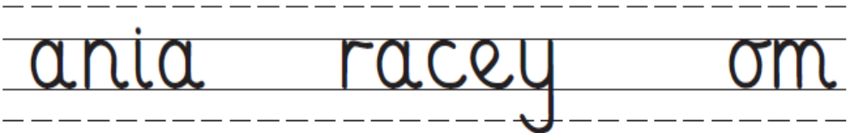

How did
you do?
Brilliant! OK I need another try.

www.collinseducation.com © HarperCollinsPublishers Limited 2011


Capital letters

Name ___________________________

Date _____________

Write over each capital letter. Follow the movement order.
Start at the .
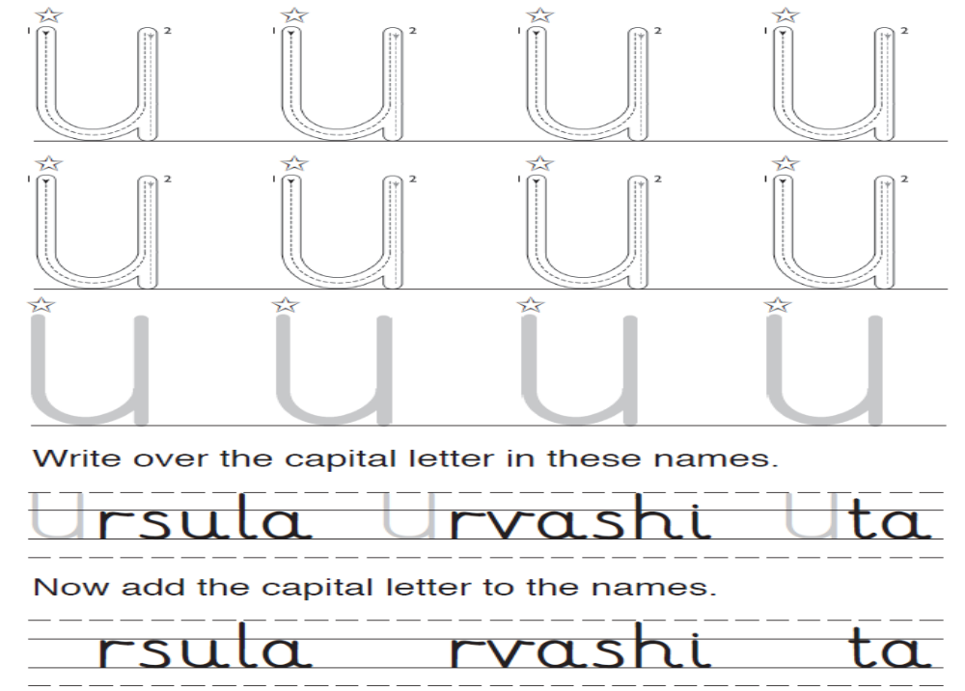

Write over the capital letter in these names.
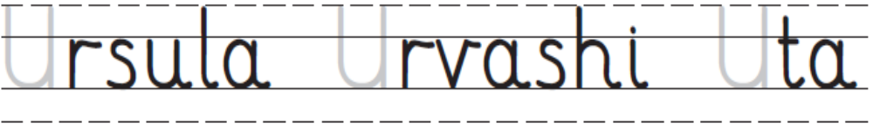

Now add the capital letter to the names.

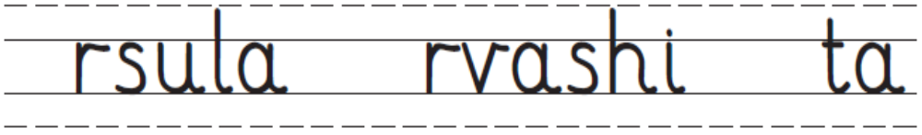

How did
you do?
Brilliant! OK I need another try.

www.collinseducation.com © HarperCollinsPublishers Limited 2011




Capital letters

Name ___________________________

Date _____________

Write over each capital letter. Follow the movement order.
Start at the .
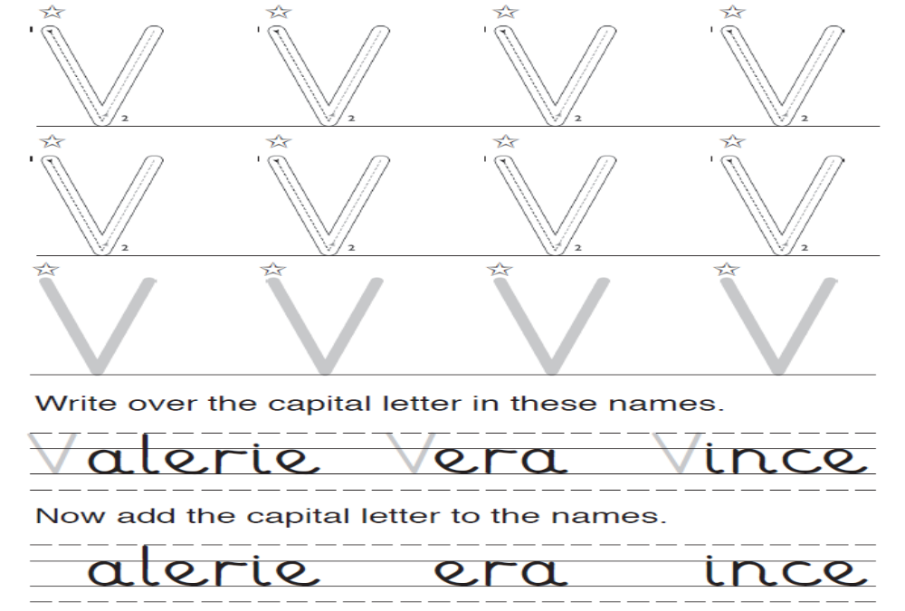

Write over the capital letter in these names.

Now add the capital letter to the names.
How did
you do?
Brilliant! OK I need another try.

www.collinseducation.com © HarperCollinsPublishers Limited 2011



Capital letters

Name ___________________________

Date _____________

Write over each capital letter. Follow the movement order.
Start at the .
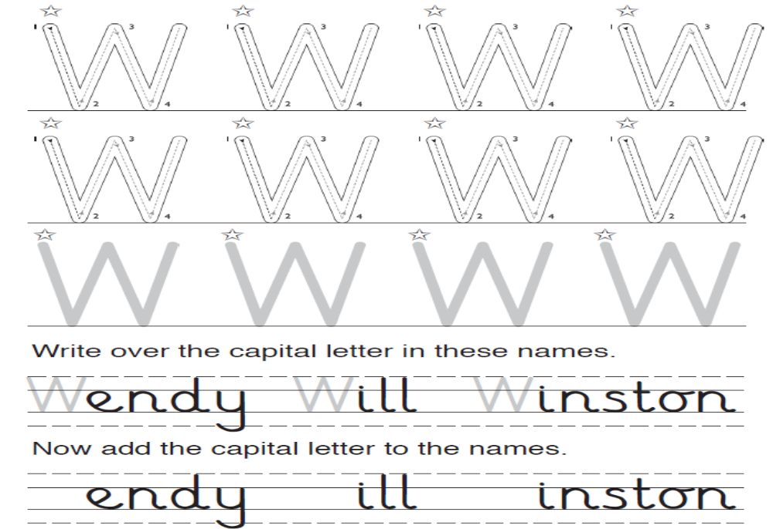

Write over the capital letter in these names.
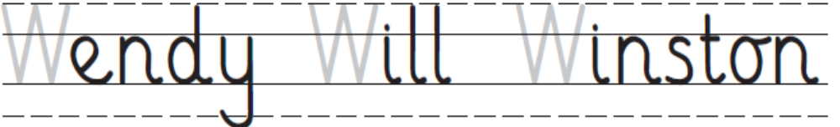

Now add the capital letter to the names.
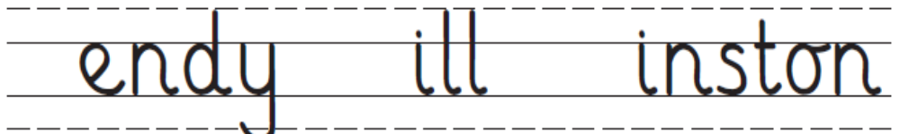
How did
you do?
Brilliant! OK I need another try.

www.collinseducation.com © HarperCollinsPublishers Limited 2011



Capital letters

Name ___________________________

Date _____________

Write over each capital letter. Follow the movement order.
Start at the .
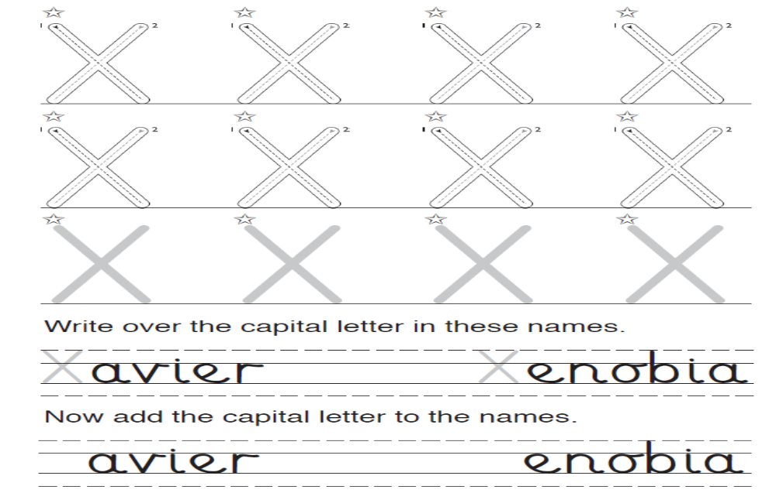

Write over the capital letter in these names.
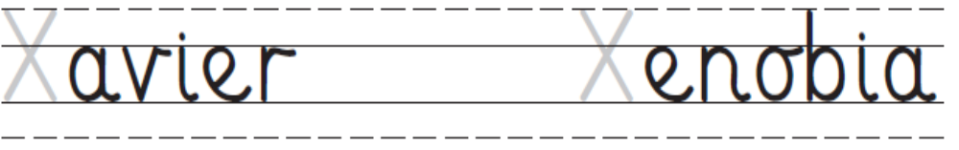
Now add the capital letter to the names.
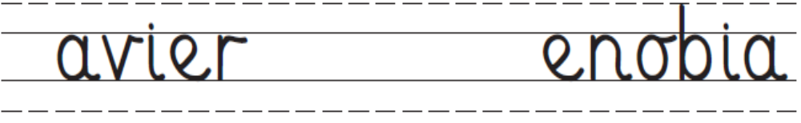
How did
you do?
Brilliant! OK I need another try.

www.collinseducation.com © HarperCollinsPublishers Limited 2011


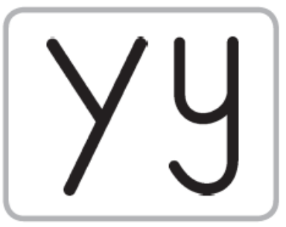

Capital letters

Name ___________________________

Date _____________

Write over each capital letter. Follow the movement order.
Start at the .
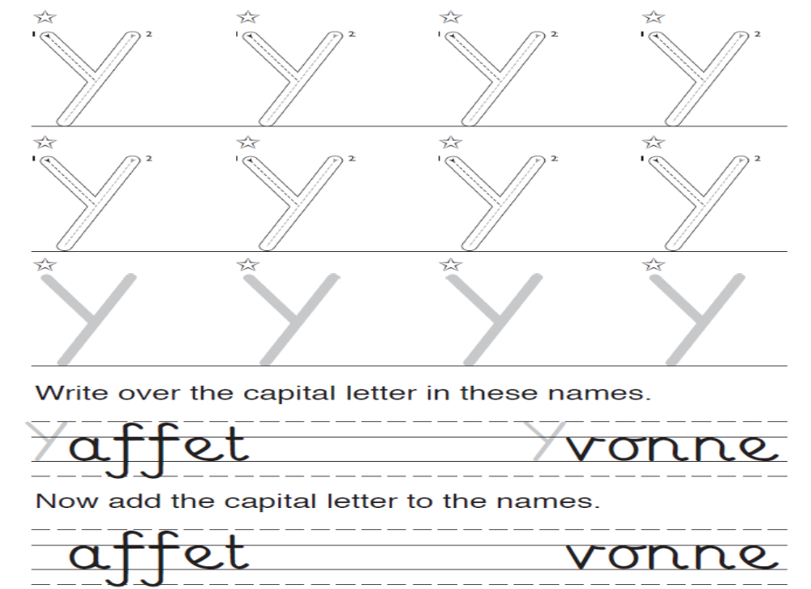

Write over the capital letter in these names.
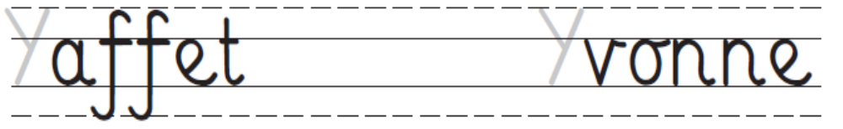

Now add the capital letter to the names.
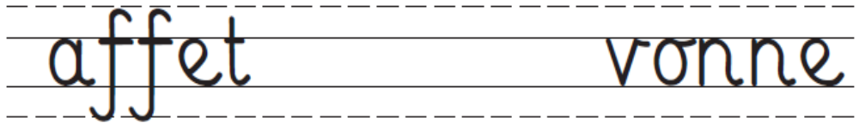
How did
you do?
Brilliant! OK I need another try.

www.collinseducation.com © HarperCollinsPublishers Limited 2011

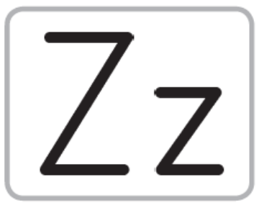

Capital letters

Name ___________________________

Date _____________

Write over each capital letter. Follow the movement order.
Start at the .
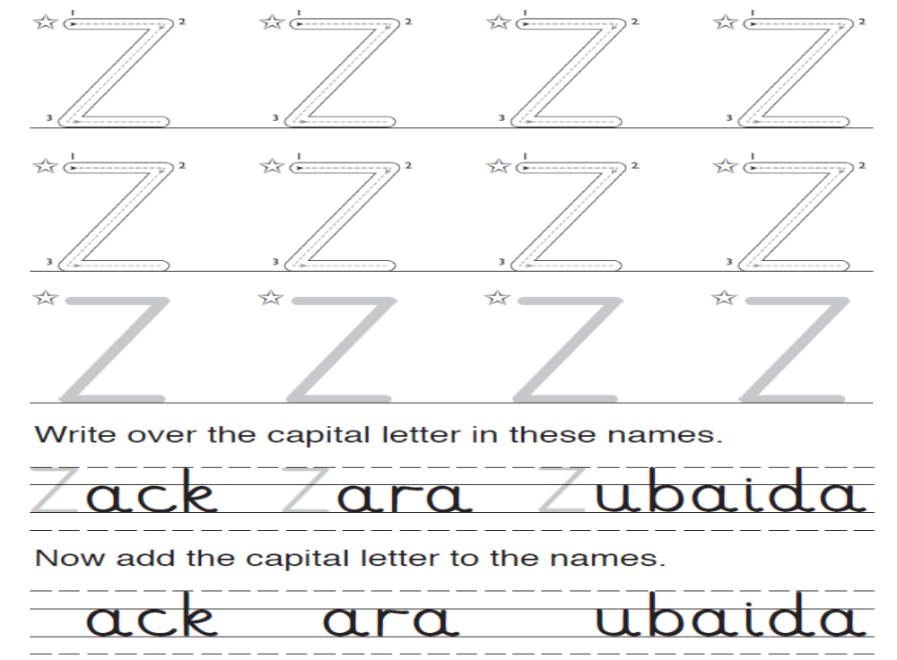

Write over the capital letter in these names.
Now add the capital letter to the names.
How did
you do?
Brilliant! OK I need another try.

www.collinseducation.com © HarperCollinsPublishers Limited 2011



Small letters

Name ___________________________ Date _____________

Write over each small letter. Follow the movement order.
Start at the .
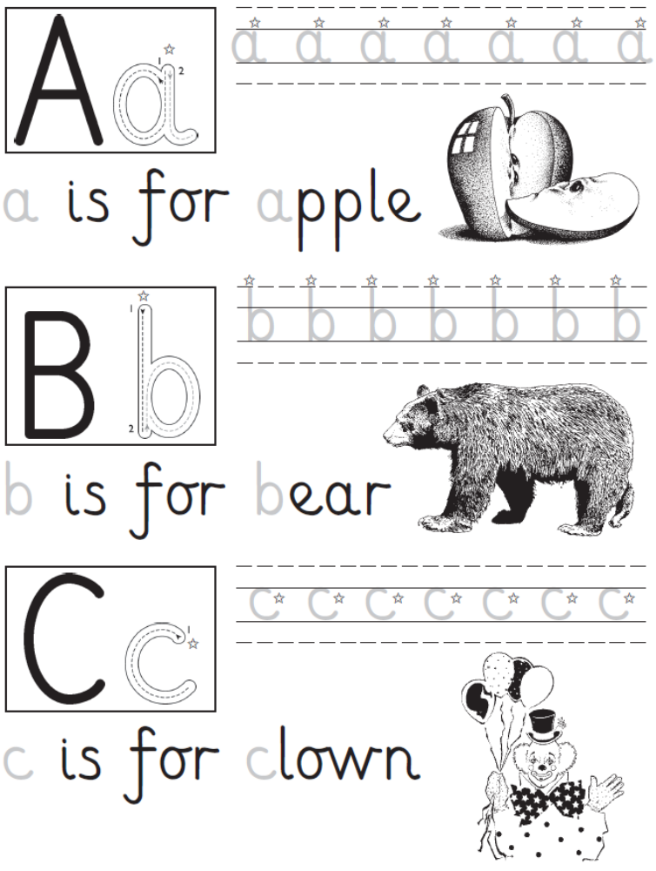

Brilliant! OK I need another try.
How did
you do?

www.collinseducation.com © HarperCollinsPublishers Limited 2011



Small letters

Name ___________________________ Date _____________

Write over each small letter. Follow the movement order.
Start at the .
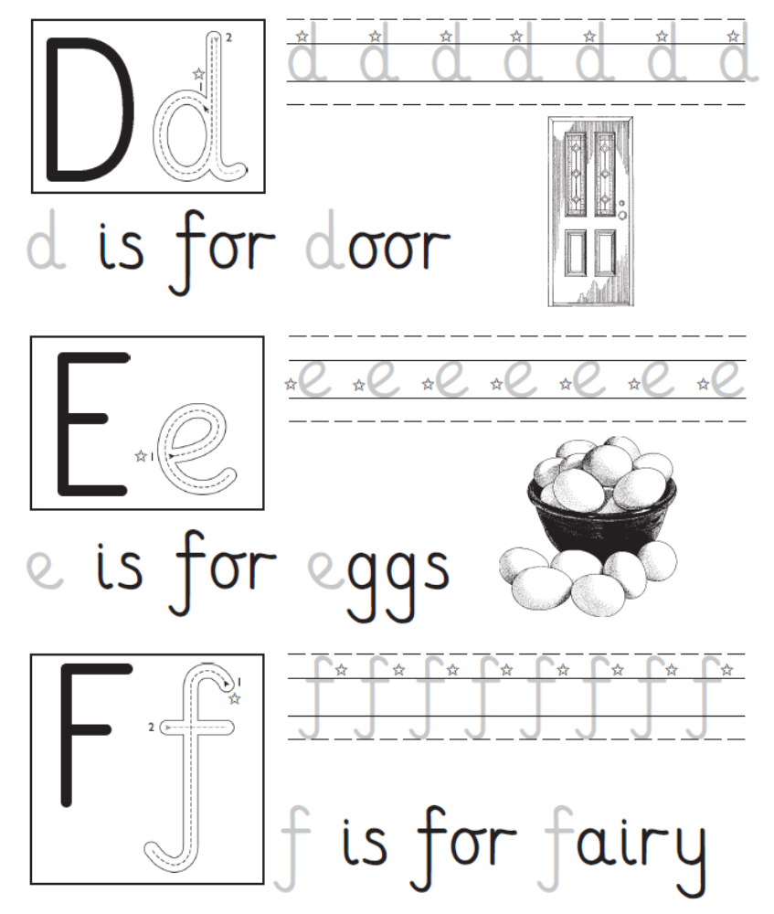

How did
you do?
Brilliant! OK I need another try.

www.collinseducation.com © HarperCollinsPublishers Limited 2011




Small letters

Name ___________________________ Date _____________

Write over each small letter. Follow the movement order.
Start at the .

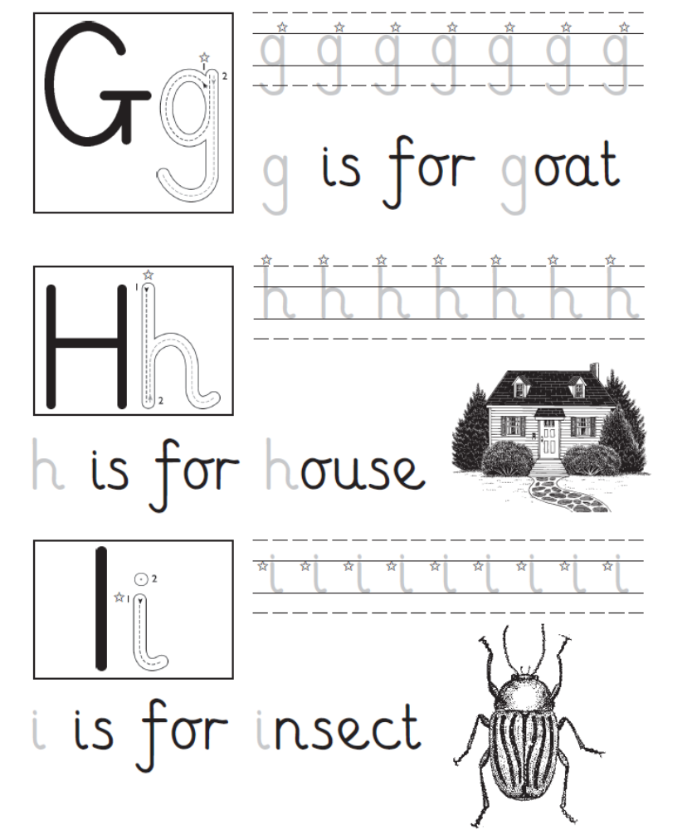

How did
you do?
Brilliant! OK I need another try.

www.collinseducation.com © HarperCollinsPublishers Limited 2011



Small letters

Name ___________________________ Date _____________

Write over each small letter. Follow the movement order.
Start at the .
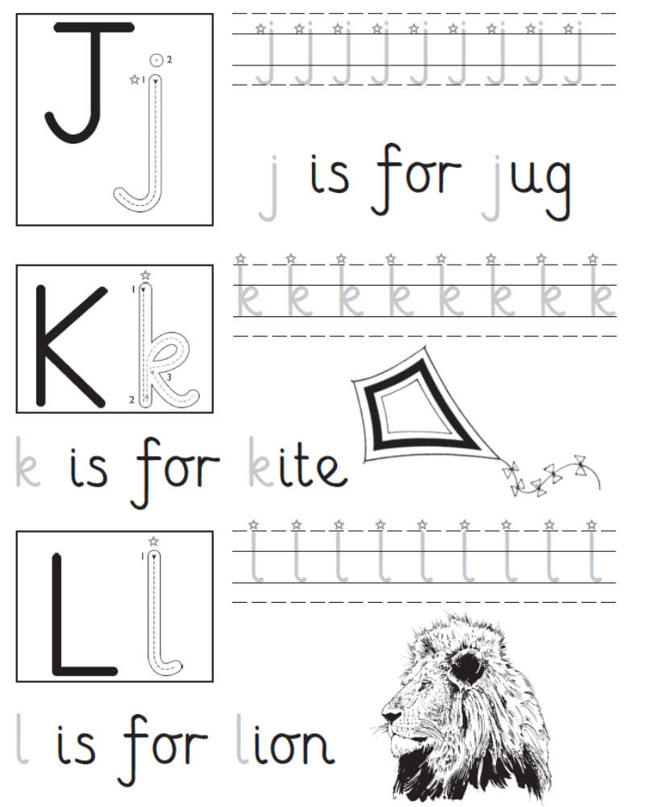

Brilliant! OK I need another try.
How did
you do?

www.collinseducation.com © HarperCollinsPublishers Limited 2011



Small letters

Name ___________________________ Date _____________

Write over each small letter. Follow the movement order.
Start at the .

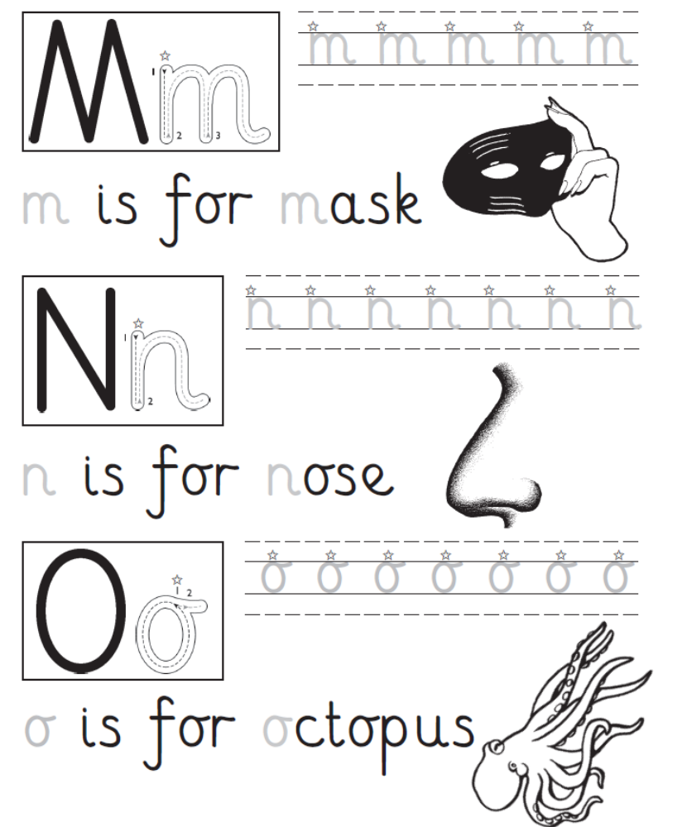

Brilliant! OK I need another try.
How did
you do?

www.collinseducation.com © HarperCollinsPublishers Limited 2011




Small letters

Name ___________________________ Date _____________

Write over each small letter. Follow the movement order.
Start at the .
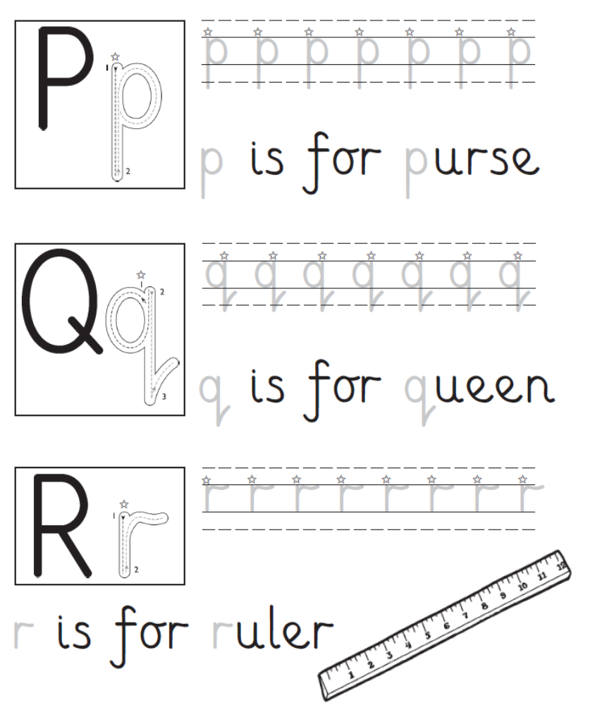

How did
you do?
Brilliant! OK I need another try.

www.collinseducation.com © HarperCollinsPublishers Limited 2011


Small letters

Name ___________________________ Date _____________

Write over each small letter. Follow the movement order.
Start at the .

How did
you do?
Brilliant! OK I need another try.

www.collinseducation.com © HarperCollinsPublishers Limited 2011



Small letters

Name ___________________________ Date _____________

Write over each small letter. Follow the movement order.
Start at the .
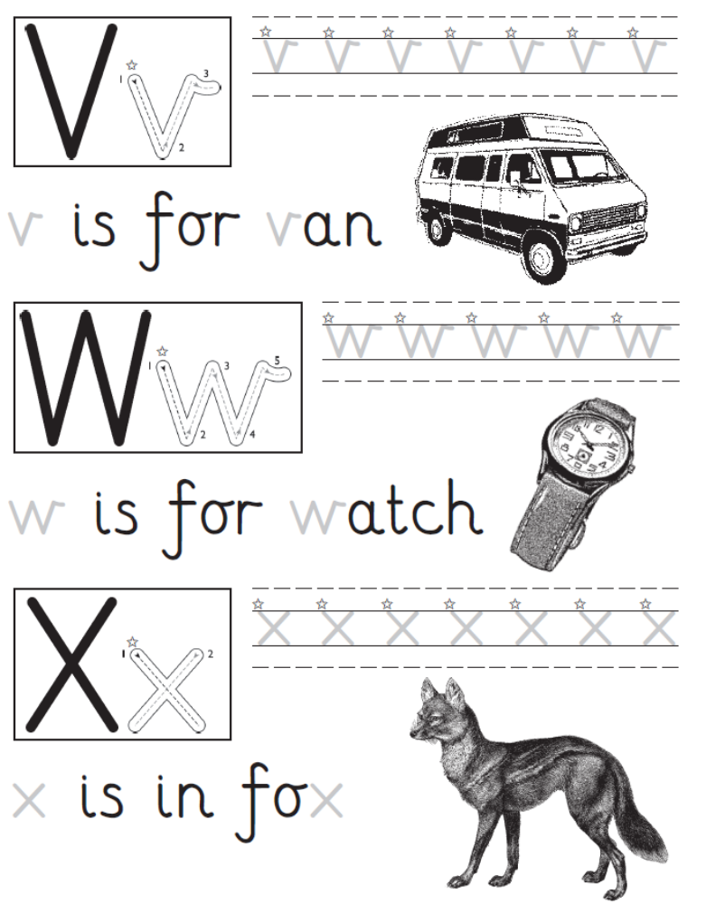

Brilliant! OK I need another try.
How did
you do?

www.collinseducation.com © HarperCollinsPublishers Limited 2011




Small letters

Name ___________________________ Date _____________

Write over each small letter. Follow the movement order.
Start at the .
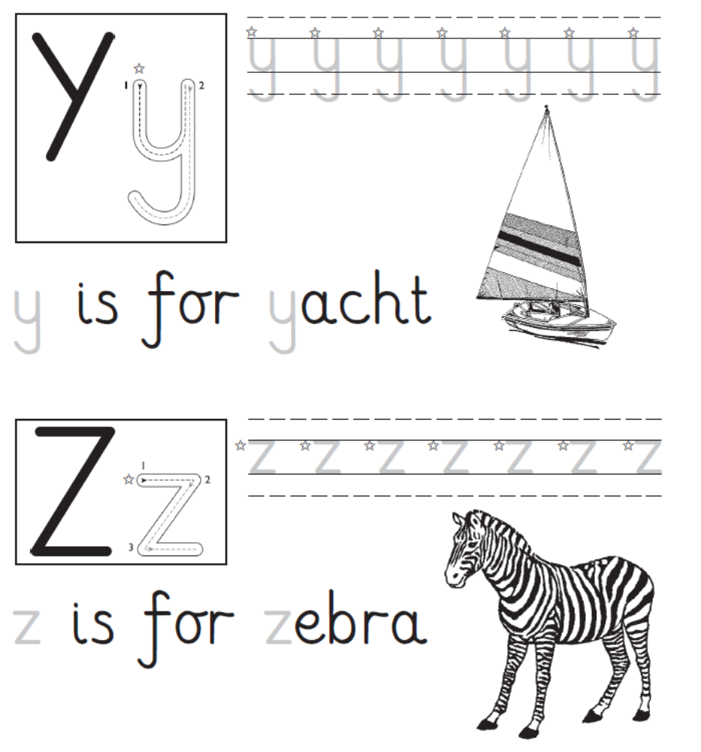

Brilliant! OK I need another try.
How did
you do?

www.collinseducation.com © HarperCollinsPublishers Limited 2011




Add the missing letters

Name ___________________________ Date _____________

Thirteen capital letters are missing from this sheet.
Can you write each one in its correct position
next to a small letter?
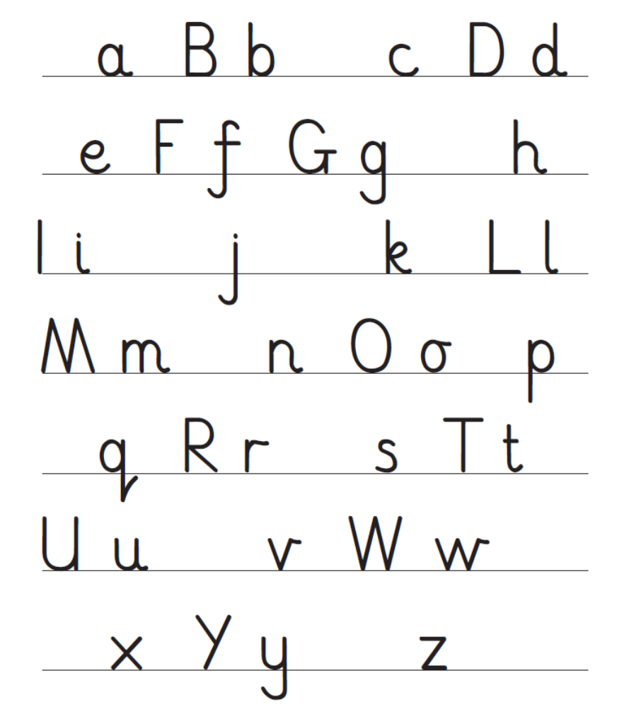

Brilliant! OK I need another try.
How did
you do?

www.collinseducation.com © HarperCollinsPublishers Limited 2011



Add the missing letters

Name ___________________________ Date _____________

Thirteen small letters are missing from this sheet.
Can you write each one in its correct position
next to a capital letter?
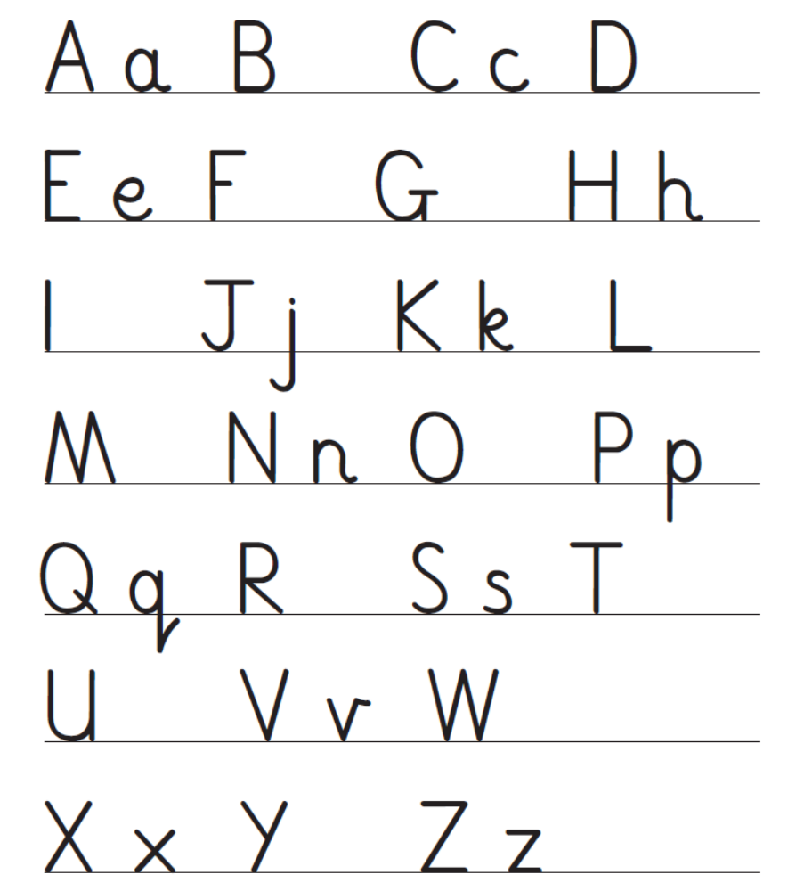

How did
you do?
Brilliant! OK I need another try.

www.collinseducation.com © HarperCollinsPublishers Limited 2011




Numbers

Name ___________________________ Date _____________

Write over each number. Follow the movement order.
Start at the .

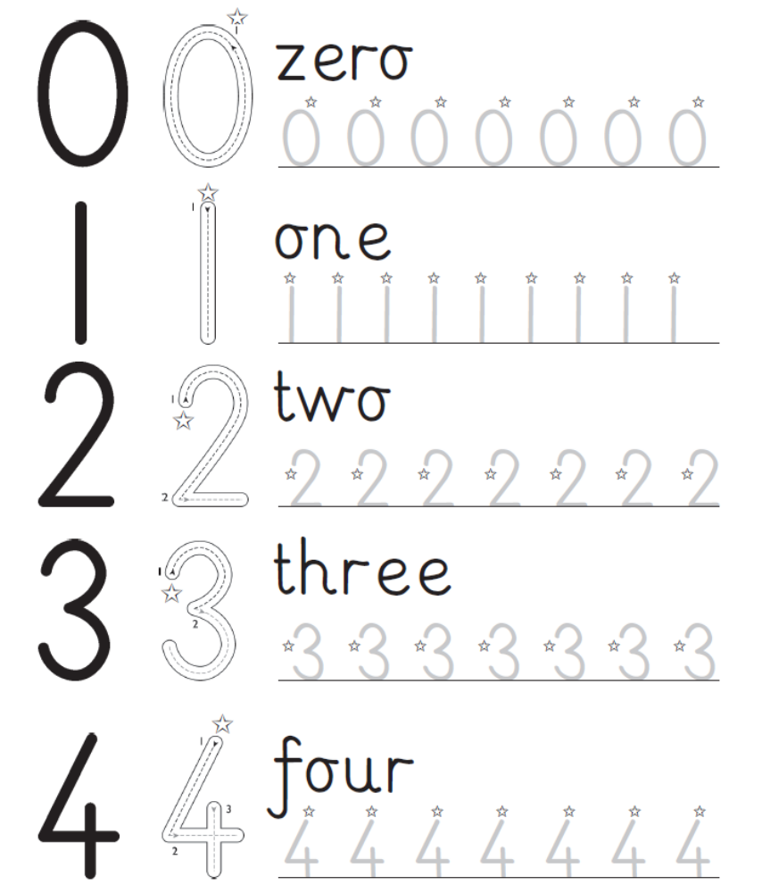

How did
you do?
Brilliant! OK I need another try.

www.collinseducation.com © HarperCollinsPublishers Limited 2011



Numbers

Name ___________________________ Date _____________

Write over each number. Follow the movement order.
Start at the .
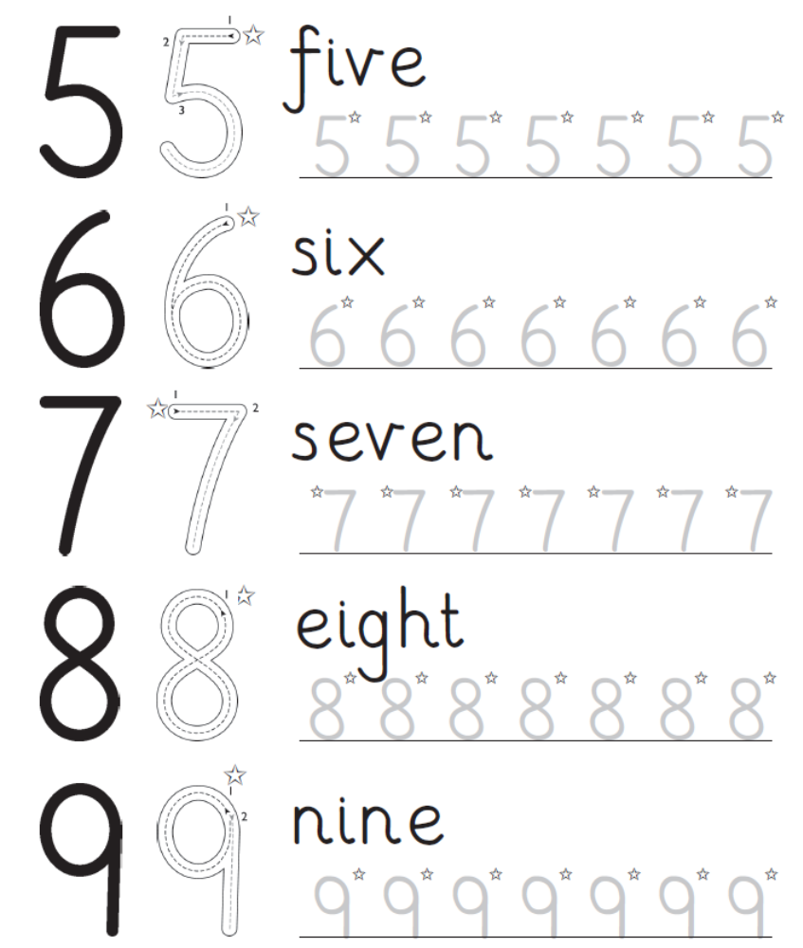

Brilliant! OK I need another try.
How did
you do?

www.collinseducation.com © HarperCollinsPublishers Limited 2011




What’s missing?

Name ___________________________ Date _____________

This rhyme contains ten numbers and four different
punctuation marks. Read the first rhyme aloud,
then add the missing numbers and punctuation marks
to the second rhyme. Do you know what the four different
punctuation marks are called?

1, 2, 3, 4, 5,
Once I caught a fish alive!
6, 7, 8, 9, 10,
Then I let it go again.
Why did you let it go?
Because it bit my finger so!
Which finger did it bite?
This little finger on the right.

Once I caught a fish alive

Then I let it go again
Why did you let it go
Because it bit my finger so
Which finger did it bite
This little finger on the right

How did
you do?
Brilliant! OK I need another try.

www.collinseducation.com © HarperCollinsPublishers Limited 2011

