|  |  |  |
| --- | --- | --- |
| **Monday 23rd March 2020 Money** | How am I doing? | |
| Teacher | Me |
| KITE – Combine £1, £2, £5 and £10, use the symbol for pounds (£). |  |  |



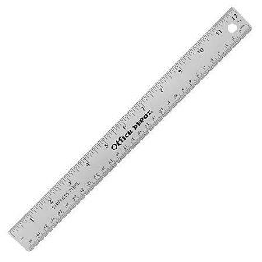

Do it

REACH

|  |
| --- |
| **Do it:**  **Use money to find the total of:**  **£10 + £2 =**  **£10 + £5 =**  **£5 + £2 =**  **£10 + £5 + £2 =**  **= £5 + £10 + £1**  **= £1 + £5 + £1**  **= £2 + £2 + 10**  **= £1 + £2 + £5** |
| **Secure it**  **Miss Jones thinks that if she has £1 and £2 and £5 she has two notes and a coin.**  **Explain why she is incorrect.** |

|  |
| --- |
| **Deepen it**  **Coco has £1 and £2 coins, £5 and £10 notes in her purse. If she picks out two coins and one note, investigate how much money she could have picked out.**  **What is she picked two notes and one coin?** |