|  |  |  |
| --- | --- | --- |
| **Thursday 26th March 2020 Money** | How am I doing? | |
| Teacher | Me |
| KITE – Combine 10p, 20p and 50p coins to make different totals. |  |  |



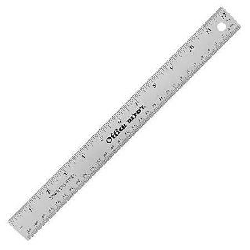

Do it

REACH

|  |
| --- |
| **Do it:**  **How much money is in each purse?** |
| **Secure it**  **Miss Jones thinks that to pay 40p she can use a 30p coin and a 10p coin.**  **Explain why she is incorrect.** |

|  |
| --- |
| **Deepen it**  **Always / Sometimes / Never**  **You can make __0p using one or two coins.**  **How many different ways can you think of?** |