St Joseph’s Catholic Primary School Council
Log Trail Fundraising Competition
£1 Entry – 1 Prize for each Key Stage
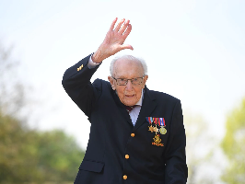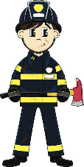

KS1
Draw a picture of a Covid Hero, this can be Nurses, Doctors, Police, Fireman, Paramedics, Carers, Bin Men, Dentists, Shop Workers, Lorry Drivers, Marcus Rashford, Captain Tom, or someone that you know that has or is still helping!
Don’t forget to include rainbows!
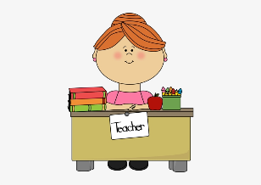
KS2
Write an account of your experience of Covid, no more than 1 side of A4, this can be a newspaper report, recount, letter to your future self. Remember to talk about how you felt and include things like the shops running out of items, washing hands, remote learning, lockdown and so on!

PLEASE HAND ALL ENTRIES WITH THE £1 TO YOUR CLASS TEACHER BY TUESDAY 20TH JULY

