Collapsing Bridge Challenge

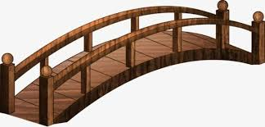

A bridge will collapse in 17 minutes.
4 people want to cross it before it will collapse. It is a dark night and there is only one torch between them.
Only two people can cross at a time.
Person A takes a minute to cross.
Person B takes 2 minutes.
Person C takes 5 minutes
and Person D takes 10 minutes
How do they all cross before the bridge collapses?

