Tuesday 31st March – Phonics
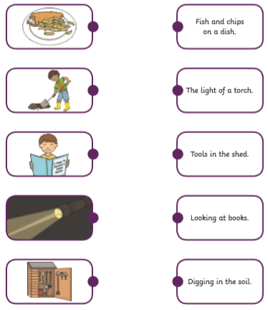
Match the picture to the caption by drawing a line between both.

