|  |  |  |
| --- | --- | --- |
| **Monday 30th March 2020 Money** | How am I doing? | |
| Teacher | Me |
| KITE – Find different combinations of coins that equal the same amount of money. |  |  |



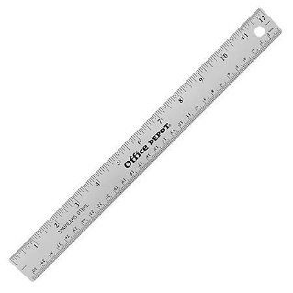

Do it

REACH

|  |
| --- |
| **Do it:**  **Make the following:**  **6p with 2, 3 and 4 coins**  **10p with 2, 4 and 5 coins**  **30p with 2, 3 and 4 coins**  **70p with 2, 3 and 4 coins** |
| **Secure it**  **Miss Jones thinks that she can make 8p with two coins.**  **Explain why she is incorrect.** |

|  |
| --- |
| **Deepen it**  **Using coins, Colin thinks he can make 8p in more ways than he can make 10p.**  **Do you agree or disagree?**  **Explain your thinking.** |